INDOT Electronic Permit System
CUSTOMERS
Version 1.0
This guide was written for use with the Electronic Permit System software version 1.0. This guide and the EPS software described in it are copyrighted, with all rights reserved. This guide and the EPS software may not be copied, except as otherwise provided in your software license or as expressly permitted in writing by Indiana Department of Transportation. All other trademarks and service marks are the property of their respective owners.
Copyright © 2016, Indiana Department of Transportation All rights reserved.

Administrator
Christine McKeon
317-233-6938
cmckeon@indot.in.gov

Last Updated
5/24/2016
Contents
System Set Up 4
Logging In 4
Forgot Username/Password 6
Logout 7
Roles and Permissions 7
Menu 7
Table Tools 8
Panel Pages 8
Items on each Panel Page 8
Hyperlinks 9
Sorting 9
Columns 10
Filtering Information 11
Export to Microsoft Excel 13
Permits 15
Permit Dashboard 15
Permits/Applications 15
Companies 19
New Permit Application/Entered Permit Application 22
Progress Bar, Next/Save, Required Fields, Back, and Cancel 22
Agreement – ALL PERMIT TYPES 24
Permit Type – ALL PERMIT TYPES 25
Checklist – Only for All Driveway Subtypes EXCEPT Private 26
Location – FOR ALL PERMIT TYPES except Railroad 26
Location – Railroad 29
Applicant Info – FOR ALL PERMIT TYPES except Railroad 31
Applicant Info – Railroads 33
Client Info – Only for Consulting firms doing work on behalf of a Client 34
Details – FOR ALL PERMIT TYPES 35
Driveway Details – Only for All Driveway Subtypes 36
Sign Details – Only for Outdoor Signs 38
Property Owner – Only for Outdoor Signs 40
Bond Info – FOR ALL PERMIT TYPES 40
Attachments – FOR ALL PERMIT TYPES 41
Review – FOR ALL PERMIT TYPES 44
Submitted Permit Application 50
In Process Actions 54
Active Permit Actions 55
Preferences 57
Permit Type and Subtype Table 59

System Set Up

Logging In
To log in to EPS, go to http://eps.indot.in.gov. Both INDOT Employees and INDOT Customers use the site; select the type of User in the upper right corner of the Log In box by clicking in the radio button next to Customers.
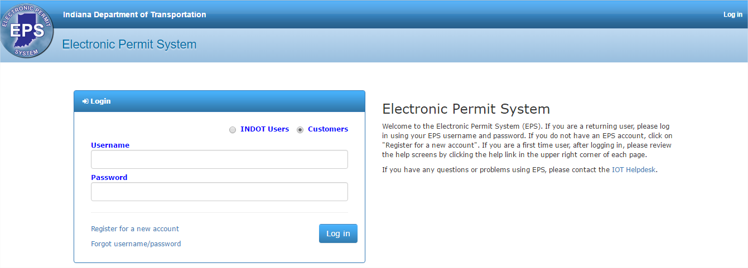

INDOT Customers should enter their EPS specific Username and Password. INDOT Customers without an EPS account should register for an EPS account. To register for a new account, click on the Register for a new account link in the Log in box. The Registration screen automatically displays after the link is clicked. Complete the fields as indicated and click Register to register to create an EPS log in.
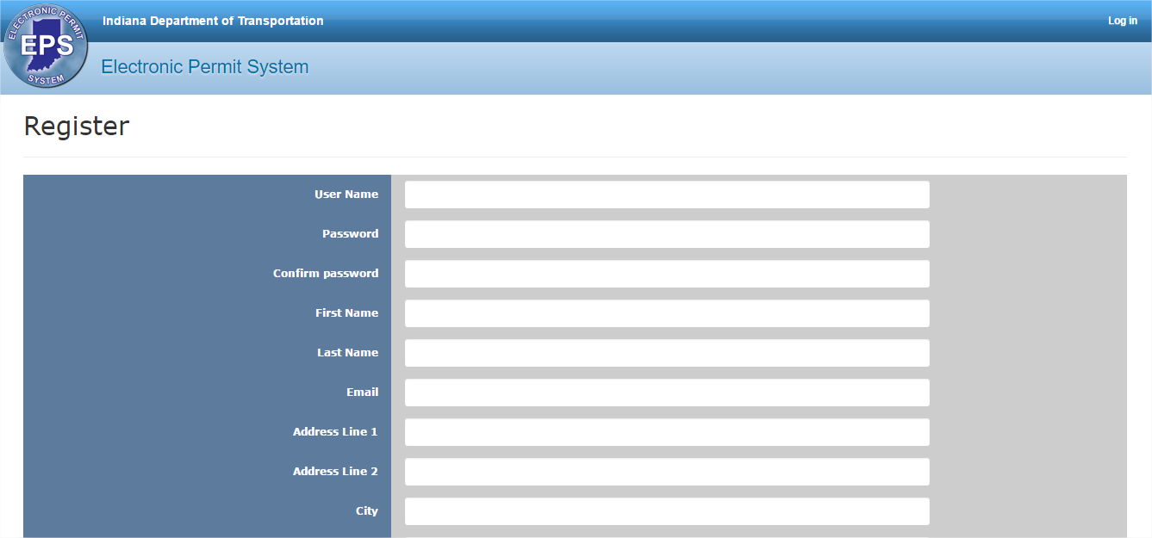
After clicking Register, the registration confirmation screen displays.
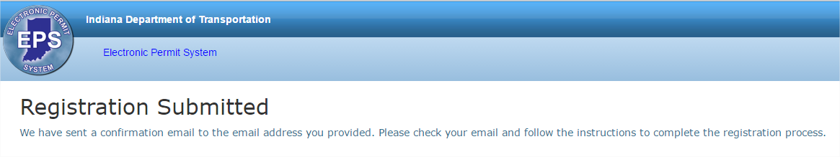

An email is automatically sent from EPS to the email address provided during registration. Follow the instructions in the email to complete the registration process.
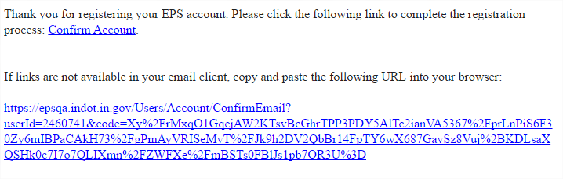

Forgot Username/Password
If the Username or Password is forgotten, click on the Forgot username/password link under the login button.
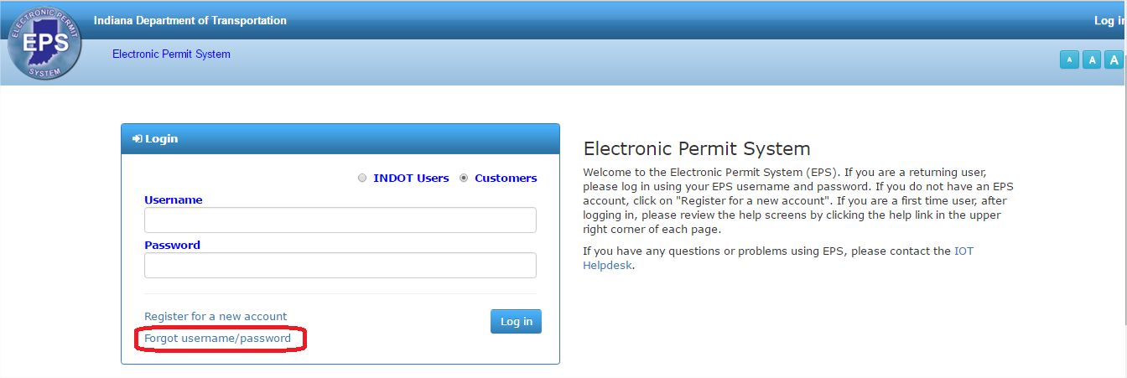
Enter the email address associated with the account and click Send Email to have the system resend the username/password.
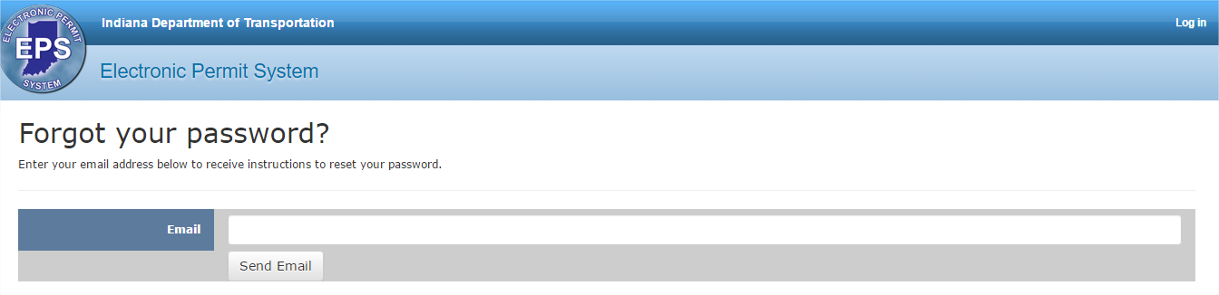
The EPS Administrator does not have the ability to reset usernames or passwords. However, if the User forgets which email address is associated with the account the EPS Administrator can see and reset the email address associated with an account.

Logout
To log out of the system, click on the Logout text in the upper right corner of the screen. The Logout text turns blue when the cursor moves over the text.
The User is taken to the Login screen.

Roles and Permissions
Users are assigned Roles and Tokens, giving them permissions to certain site features. Users without permissions to certain features see grayed out records and options (or no options/icons at all) on those screens.

Menu
The features of EPS are separated into categories and can be accessed by using the menus at the top of the screen. The menus are available from any page in EPS.
Click on a menu or hover over it to display any submenus. Click on a submenu option to display that section of EPS.
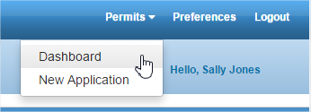

Table Tools
Certain features are the same any time a table is used in EPS. These include navigating using Panel Pages, the Items on a Panel Page, Hyperlinks, Sorting, Columns, Filtering, Grouping Columns and Exporting to Microsoft Excel.

Panel Pages
Use the Next and Previous buttons to navigate to subsequent pages or click the End or Beginning buttons to jump to the very last or very first page.
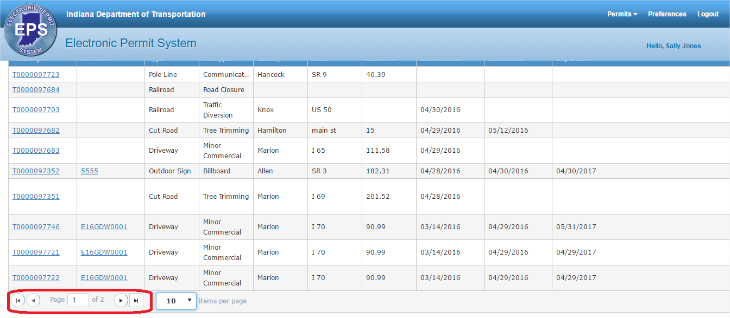
The Status Bar changes depending on what Panel page is displayed. For example, the Status Bar below displays on Page 2 and shows Items 11-17 of 17.

Items on each Panel Page
By default, Panels display 10 Items per Page. However, this may be changed.
Click on the Items per Page dropdown and select 10, 25, 50, 100, 500 or 1000 from the list. 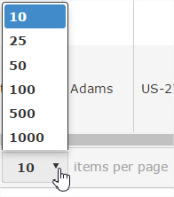

Hyperlinks
Text in the columns, such as the Tracking # or Permit #, sometimes displays as blue. Clicking on the text will take the User away from the table and open up the Permit application.
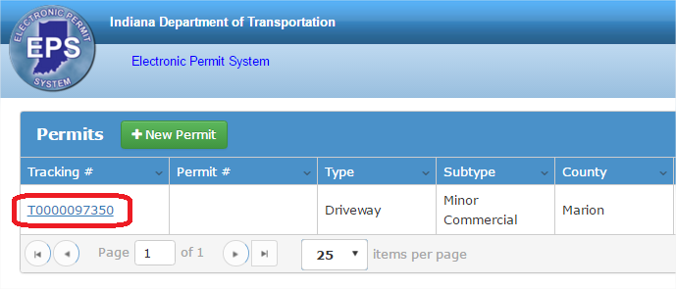

Sorting
Data in Panels may be sorted in ascending or descending order numerically (smallest to largest or largest to smallest), alphabetically (A to Z or Z to A) or by date and time (oldest to newest or newest to oldest).
Click on the column heading of the field to be sorted. In the example below, the list of Permits is sorted by the County (ascending) by clicking once on the County column heading. A triangle indicating the direction of the sort appears next to the column heading.
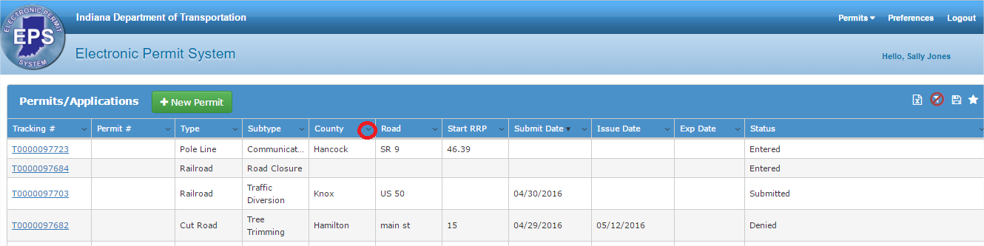
To res-sort (descending), click again on the column heading.
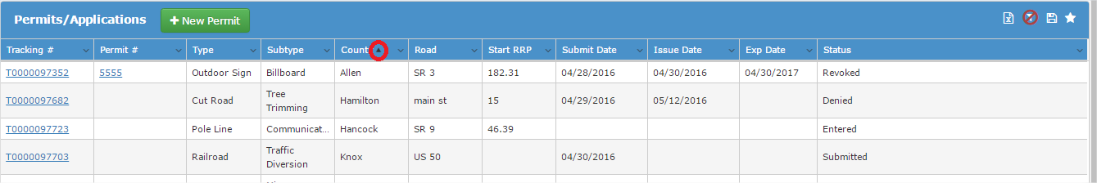
By default, Panels display sorted by the first column.
Sorts are not saved. The next time the Panel is opened, it is sorted by the first column.
Columns can also be sorted by clicking on the small arrow in the far right of the column to display the dropdown menu. Select to Sort Ascending or Sort Descending. Click on the arrow again to display the menu again and change the sort.
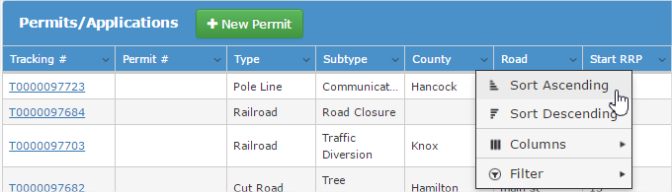

Columns
Users can control which columns display in a table by clicking on any of the column headings. Hover over Columns submenu to display a list of all available columns to display for a Table. Any columns currently on display have a check mark in the check box to the left of the column name. Click in an empty check box to make the column visible. Click in any box with a check mark to remove the check mark and hide the column.
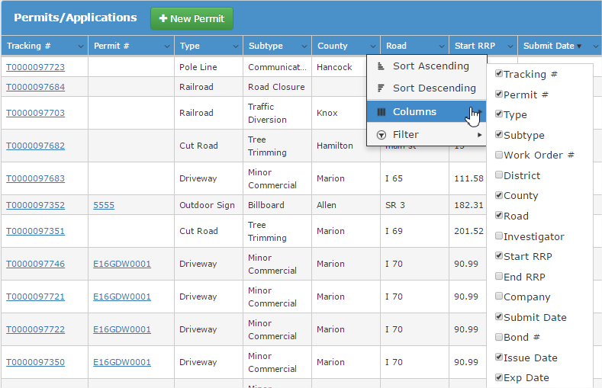
Column display selections are not saved. The next time the Panel is opened, all default columns display.

Filtering Information
Data in Panels may be filtered so only particular content displays. For example, the Permits table below shows that there are 16 items. A filter may be applied so that only those Permits with a Status = “Submitted” are shown in the list.
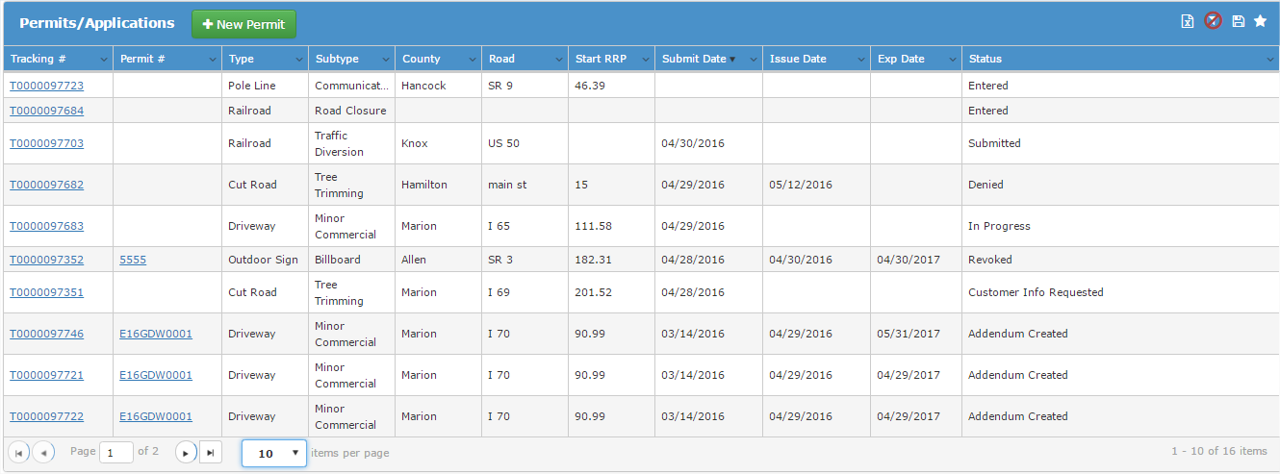
Users can filter information in a table by clicking on any of the column headings. Hover over Filter submenu to display the filter fields.
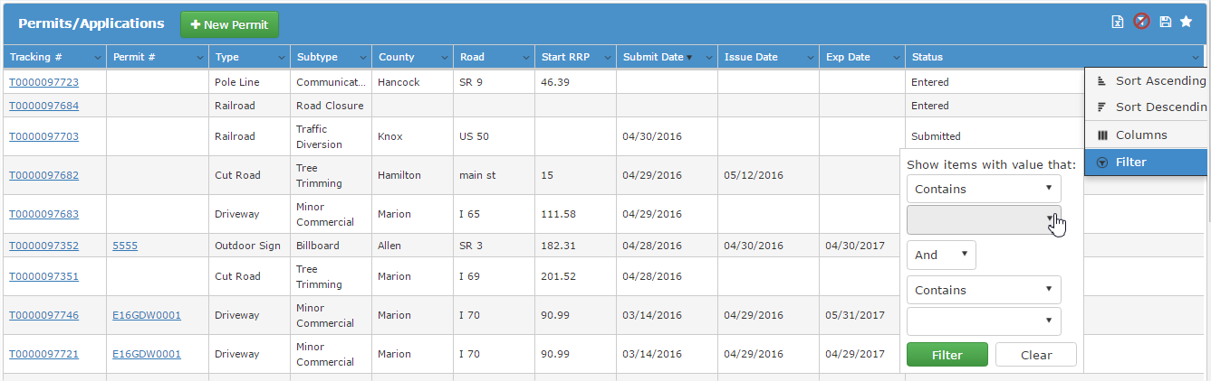

Select the operator “Is equal to” from the dropdown menu and enter the value “Submitted” in the text box (not case sensitive). A list and description of available operators is below.
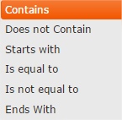 | Operator | Description
 | Contains | Enter any character(s) or number(s) in the value to include in the results (no wildcards). For example, Type Contains “crash” would return all records with the word “crash” as their Type.
 | Does not Contain | Enter any character(s) or number(s) in the value to exclude from the results. For example, Type Does not Contain “crash” would return all records that do not have the word “crash” as their Type.
 | Is equal to | Enter the exact value to include in the results
 | Is not equal to | Enter the exact value to not include in the results
 | Ends With

Depending on the type of field, the filter might be a text box, selecting a value from a dropdown (like County or Status), or a date field with a calendar.
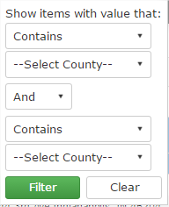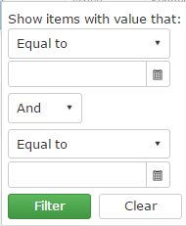
To apply a second filter, select “And” or “Or” from the dropdown and complete a second filter. Click Filter to filter the table, or click Clear to return to the table without applying the filter. To apply additional filters to the filtered list, click on the Filter submenu in the column to filter.
The filtered list of 1 record displays.
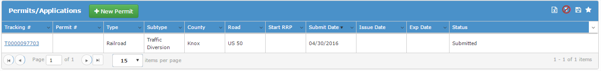
The column menu icon will have a white box around it once a filter is applied. To remove the Filter, click on the column name and select the Filter submenu. Click Clear to remove any filters on the column.
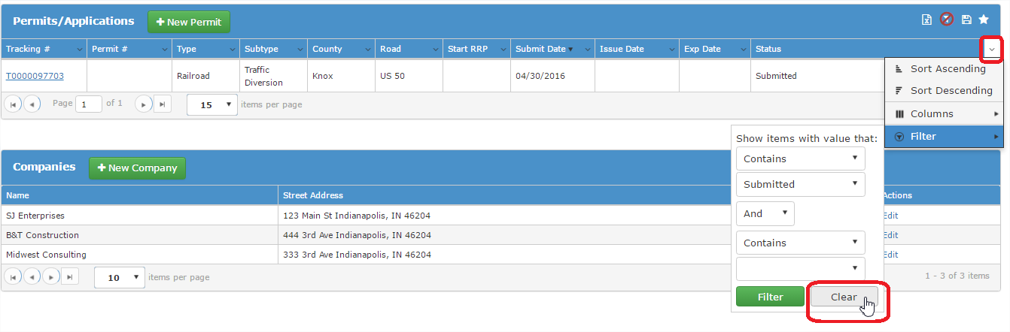

Export to Microsoft Excel
Information in Panels may be exported to Excel by clicking on the Export to Excel icon in the title bar of the Panel.
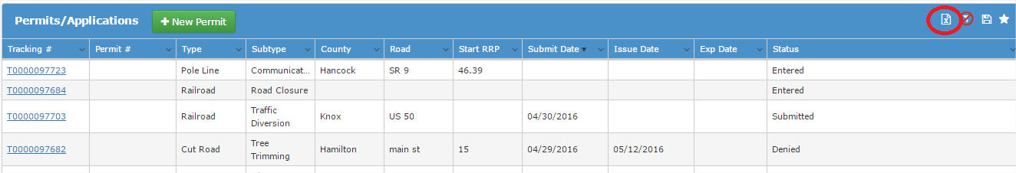
At the File Download dialog box, click on the Open button to view the data in Excel or click the Save button to save the data in an Excel file.
If saving, choose the location to store the file and click on the Save button.
By default, the file type is Microsoft Excel 97-2003 Worksheet.
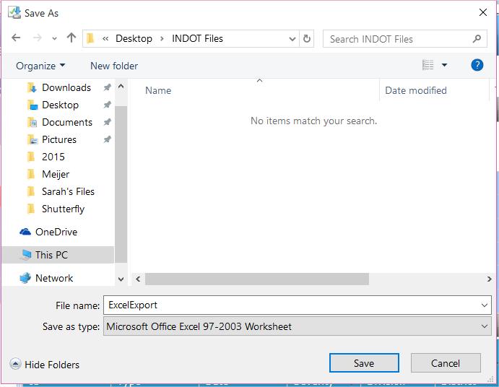
The download’s progress displays in a dialog box, as shown below. When complete, click on the Open button to view the data in Excel or click on the Open Folder button to open the file’s location.
Whether viewing or opening from a saved file, the data displays in Microsoft Excel.
Unless a Filter has been applied, every record in the list is exported.

Permits
The Permits menu provides access to the Permit Dashboard and starting a New Application.
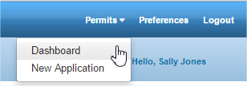

Permit Dashboard
The Permit Dashboard provides quick access to any Permit applications associated with the User’s account as well as a place to add and update Company information (when applicable).
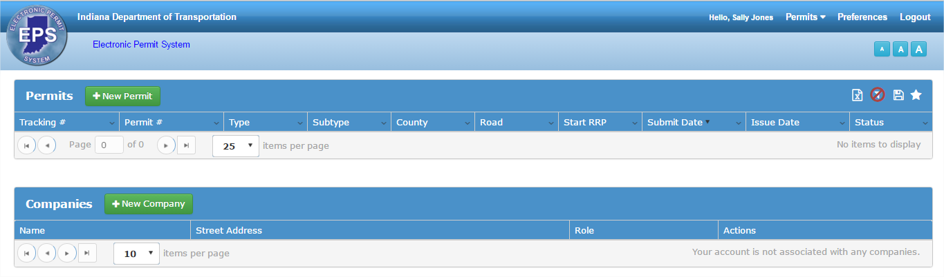

Permits/Applications
The Permits/Applications section allows Users to add, view and edit permit applications. All of the user’s created permits display, as well as any permits associated with the companies the user is associated with. See Companies for more information on companies.
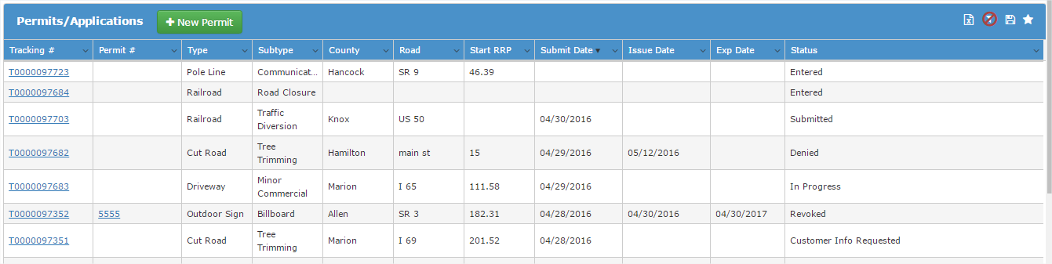
Permits created by other company users that have NOT been submitted (in a status of Entered) will NOT display in the Permits table.

To add a new permit application, click on the New Permit button in the Permits table header.
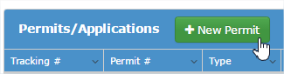
The screen will refresh and display the beginning of the permit application.
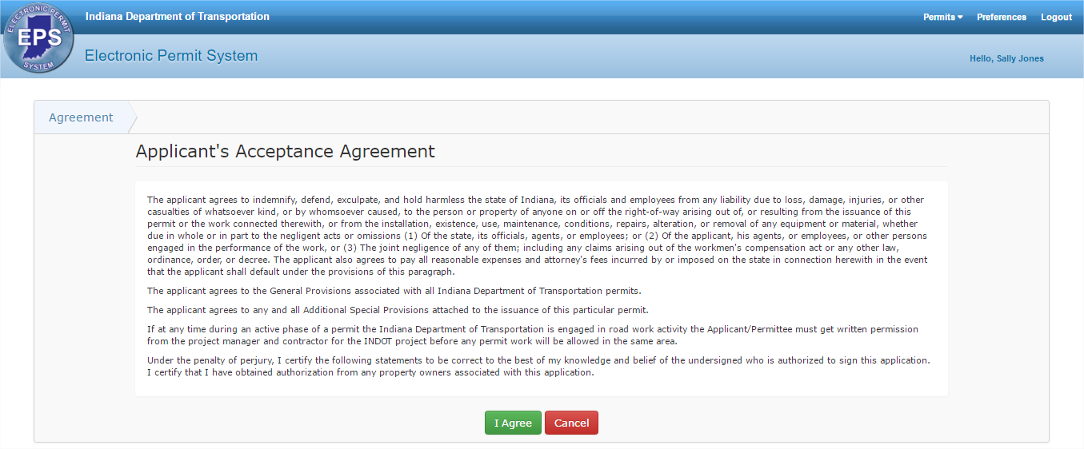
To edit or view an existing permit application, click on the blue tracking # (or permit # once issued) to open the permit application.
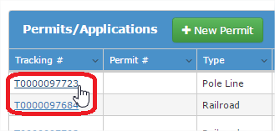

In the Permits table header, there are four icons that allow users to Export to Excel, Clear Filter, Save Filter and Apply Saved Filters.
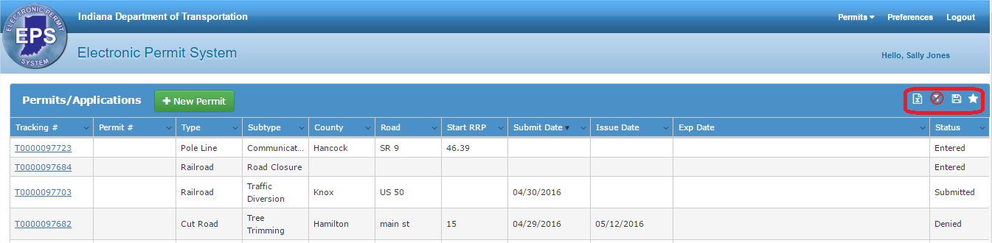
Click on the Export to Excel icon to export the Permits table to Excel. Click here for more information on exporting to Excel.
Click on the Clear Filter icon to clear any filters applied to the table. Click here for more information on filtering.
Click on the Save Filter icon to save the current filters and column selections/order for future use. Click here for more information on filtering. Enter a name for the group of filters and check the Default check box if this filter should be used by default each time the table is displayed.
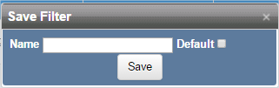
If no filters have been applied to the table, there is no filter to save.
Click on the Apply Saved Filters icon to apply a saved group of filters to the Permits table. The list of saved filters displays. The filter selected as the Default filter has true in the Default column; all others have false in the Default column. Users can Delete, Edit or Apply saved filters.
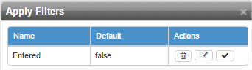

Click Delete to delete a saved filter. Click OK at the confirmation message to delete the record, or click Cancel to return to the table without deleting the record.
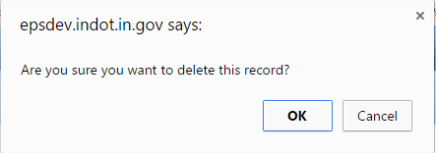
Click Edit to edit the name of a saved filter. Make any necessary changes and click Update to save the changes or click Cancel to return to the Apply Filters table without making changes.
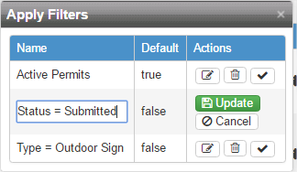
Click Apply to apply a saved filter. The Permits table will update to display records matching the saved filter.

Companies
The Companies section allows Users to associate themselves to a company.
To add a new company, click on the New Company button in the Companies table.
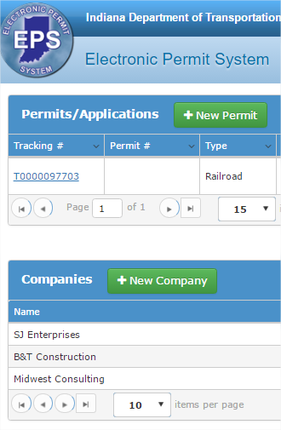

Enter the company information and click Save to save the company or click Cancel to return to the Permit Dashboard without adding a new company.
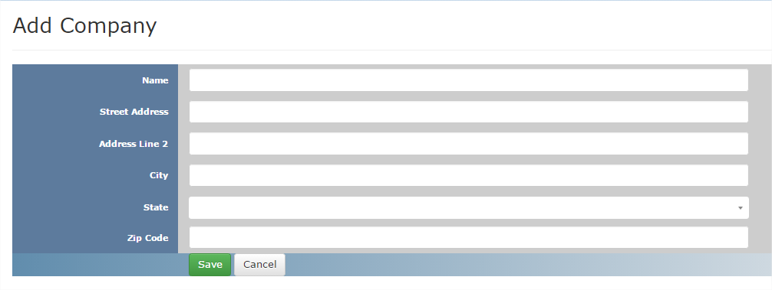
Upon saving the new company information, the screen will reload to display the Company Details page. Click Edit to edit company information. Click Back to List to return to the Permit Dashboard.
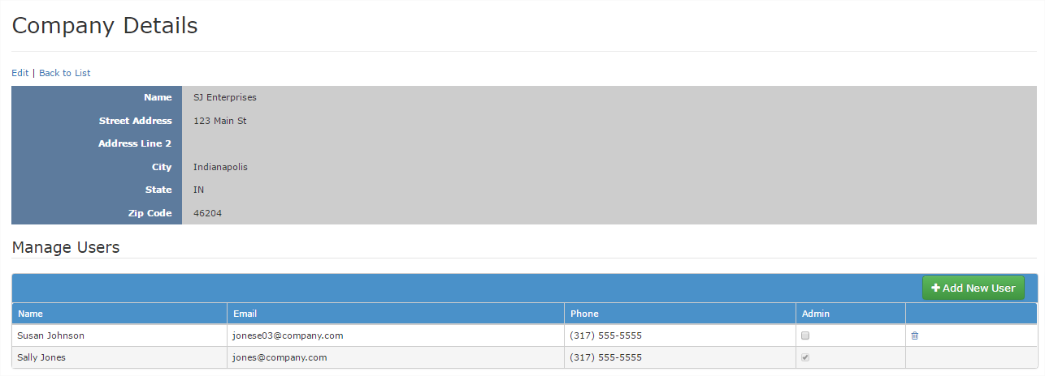
The Company Details screen is available to Company Administrators and can be accessed after the company is created by clicking on the Edit link in the Company table on the Permit Dashboard screen.

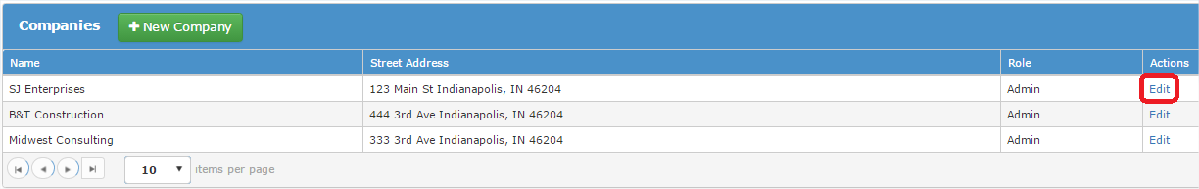

The user who created the company will automatically be assigned the Admin role for the company. To add additional users, click on the Add New User button.
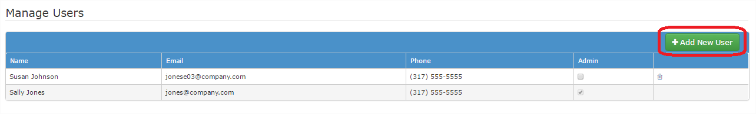
Only Company Administrators have the ability to add users to the Company.
Fill out the email address, name and phone number of the Company user. Click in the check box by Admin if the user will be an administrator. Marking a user as an Admin allows them to add users to the company and edit the company information. Click Update to add the user or click Cancel to return to the Manage Users table without adding a company user.
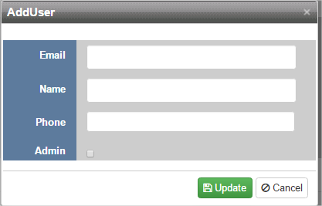
If the new company user already has an EPS account, EPS will recognize the email address and will override anything manually entered with the new user’s registered information.

The new company user is added to the table. Click in the check box to mark the user as an admin. Marking a user as an Admin allows them to add users to the company and edit the company information. Click the Delete icon to remove the user from the company.
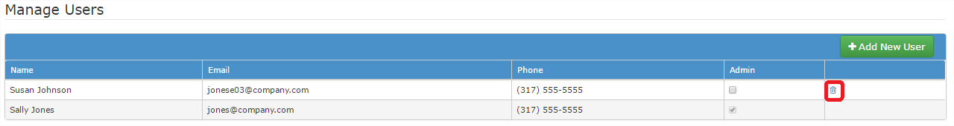
Once a user is added to a company, the company will automatically show up on the Permit Dashboard upon the User’s log in. Users can be associated with more than one company.
Any permits associated with a user’s company will display in the Permits/Applications table, even if the user did not create the permit application.

New Permit Application/Entered Permit Application
To start a new permit application, either select New Application from the Permits menu or click New Permit on the Permit Dashboard screen.
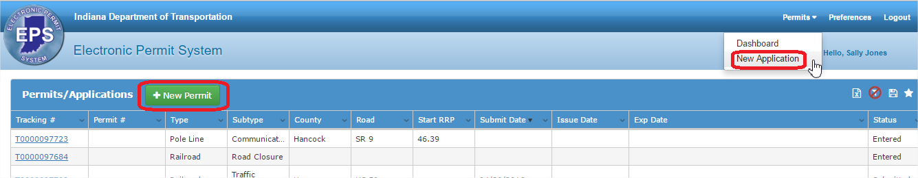
A Permit Application is divided into sections; each section is explained below. Each application requires basic information and certain Permit Types require special informational sections, which are noted in the headers below.

Progress Bar, Next/Save, Required Fields, Back, and Cancel
At the top of the screen, the Progress Bar displays the different steps in the Permit Application process and where the User is in that process.
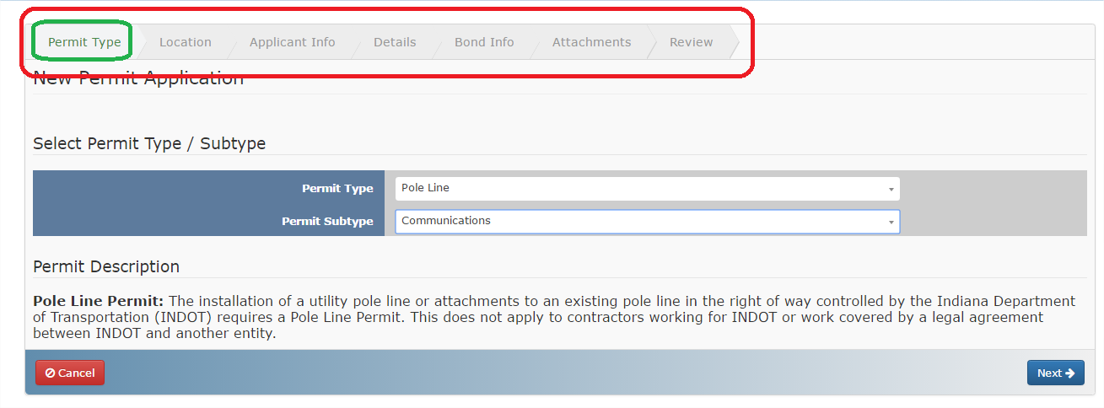
If a User has not yet accessed a section via the Next button, the title text will be grey.

Click the Next button to progress to the next screen in the application process. Each time the Next button is clicked, the application data is saved.
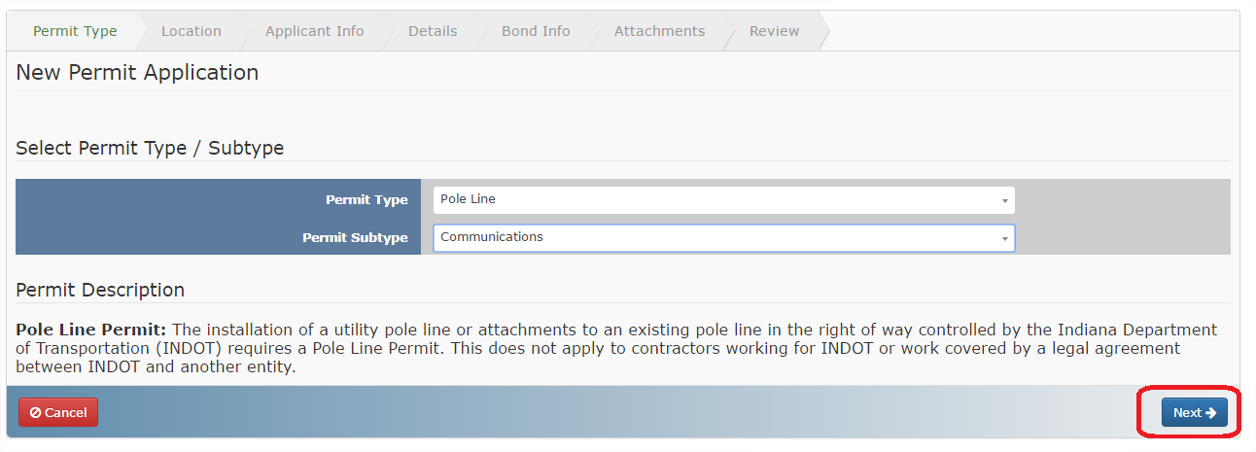
After clicking the Next button on the Permit Type screen the Permit is assigned a Tracking Number and is given the permit status as Entered. If you leave the Permit Application screen by any way except clicking Cancel the application will be saved and displayed in the Permit Dashboard Permit table. Click on the Tracking Number to open the Application on the screen last saved/visited.
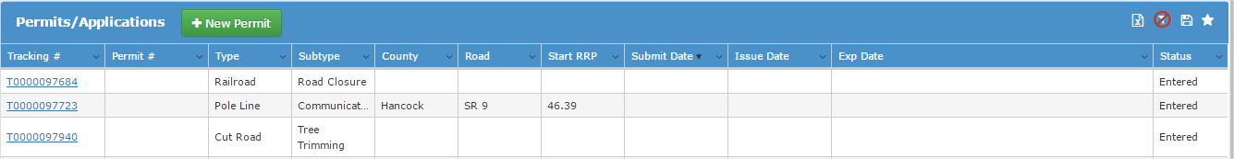
Each screen has required fields that must be completed before moving to the next section. If a required field is not completed when the Next button is clicked, a warning message will alert the User which fields are incomplete and a warning icon displays by the incomplete field. Once all required fields are complete the Next button will take the User to the next section.
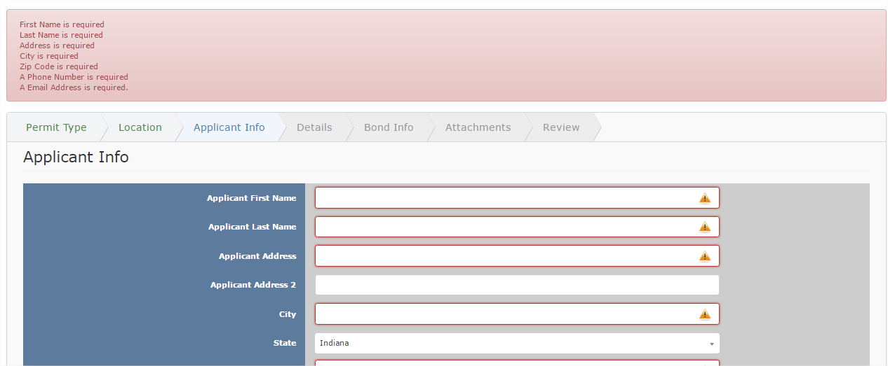

To return to a previous application screen, click the Back button.
To Cancel a permit application, click on the Cancel button at the bottom left of the screen.
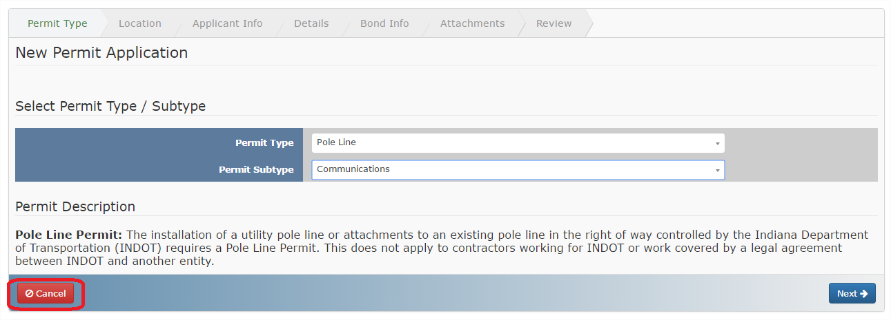
At the confirmation window, click Yes to cancel the application and delete it from the system, or click No to return to the permit application without removing the application.
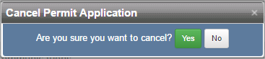

Agreement – ALL PERMIT TYPES
Read the terms and click I Agree to accept the terms and start the application or Cancel to stop the application creation process.
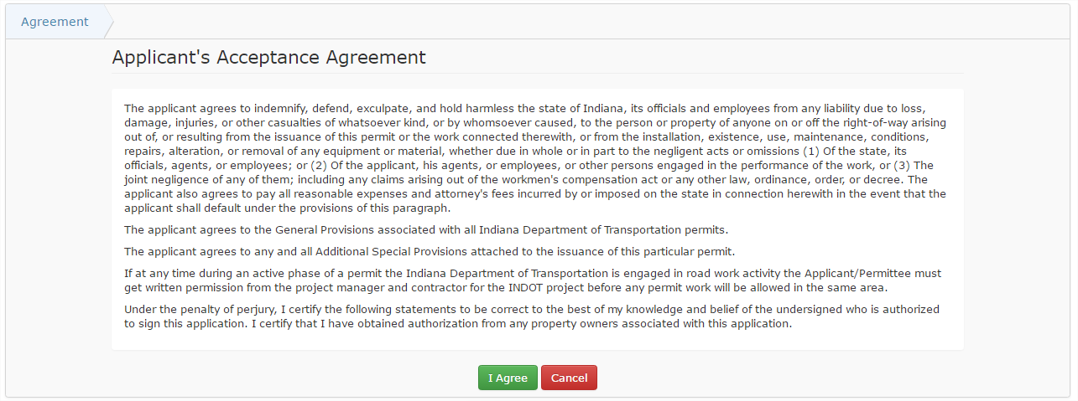

Permit Type – ALL PERMIT TYPES
Select the Permit Type from the Permit Type dropdown. The Permit Subtype dropdown menu options change based on the selected Permit Type. Once the Permit Type and Permit Subtype are selected, click Next to continue the permit application process or click Cancel to return to Permit Dashboard without creating a permit application.
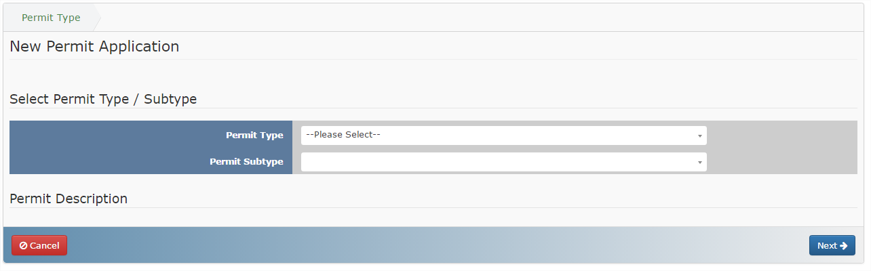
Once a Permit Type and Subtype are selected and the Next button is clicked, the Permit Type and Subtype cannot be changed. In order to change the Permit Type or Subtype the original permit application must be Cancelled and then a new application needs to be created.

Checklist – Only for All Driveway Subtypes EXCEPT Private
The Checklist section displays a listing of the information needed to submit a Commercial Driveway permit application. Click on the blue Click here links to open PDFs of information as necessary. Once the User has all required documentation, proceed to the next section by clicking on the Next button.
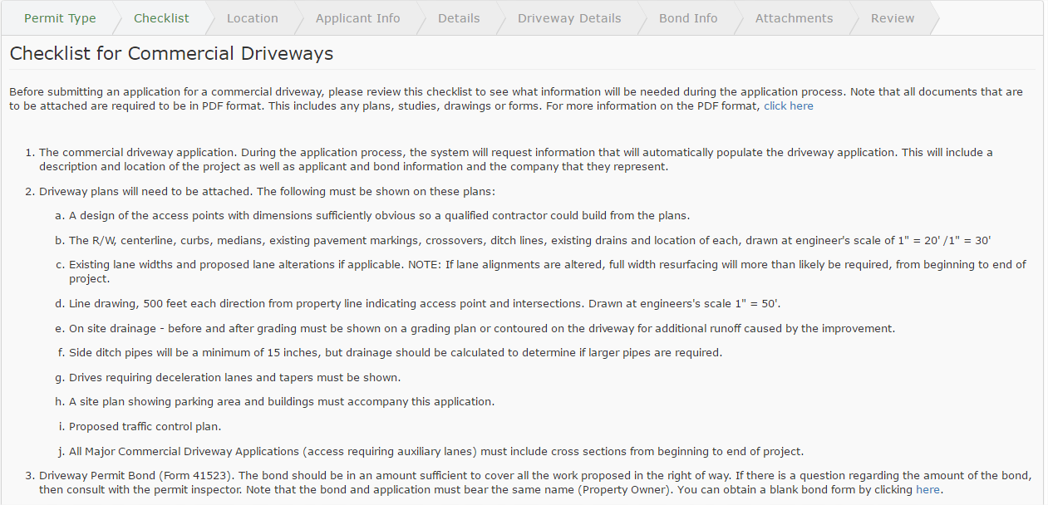

Location – FOR ALL PERMIT TYPES except Railroad
Indicate the location associated with the permit application in the Location section. Use the mouse scroll wheel to zoom in and out, or use the zoom in/out buttons to zoom in and out. Enter an address, city, intersection, etc in the Search box 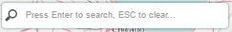and click Enter to zoom to a specific area on the map. Click and drag to move the map if necessary. Click the Layer Selector in the upper right corner of the map to select the map display from Hybrid to another selection (grayscale, streets, aerial) 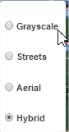.
The initial map is zoomed out to display the state of Indiana and the Permit Details fields are blank.
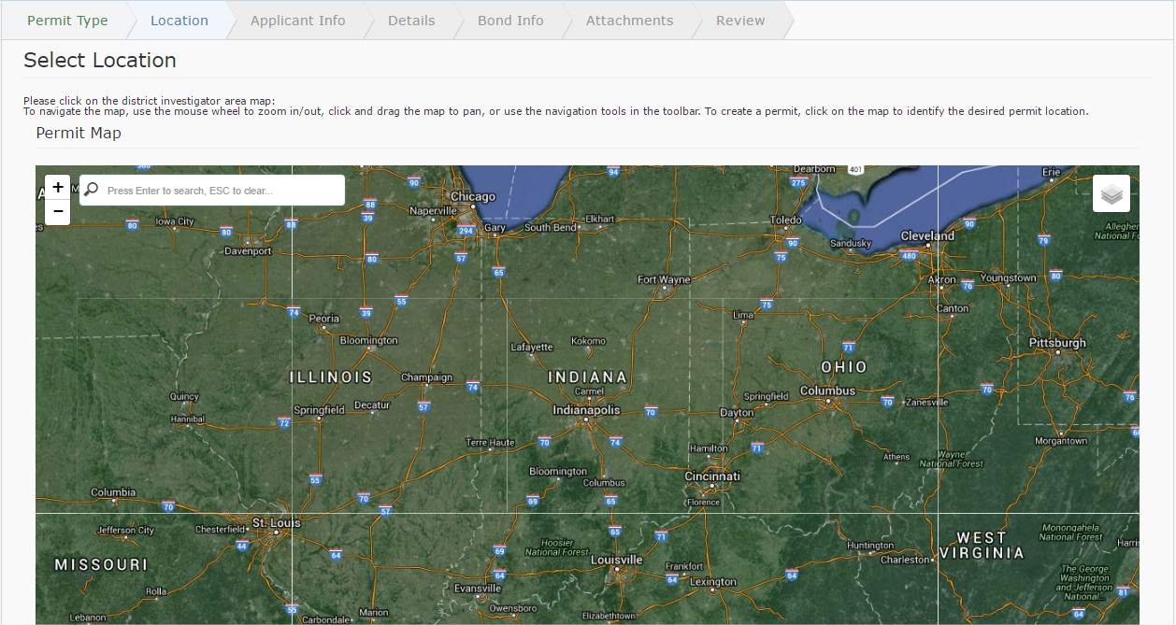

Click on the map in the exact location of the desired permit application. A blue pin will appear on the map to indicate the permit application location. If the permit application location pin is in the wrong location, click on the map again in the correct location to move the pin. The Permit Description fields will automatically populate based on the location of the pin.

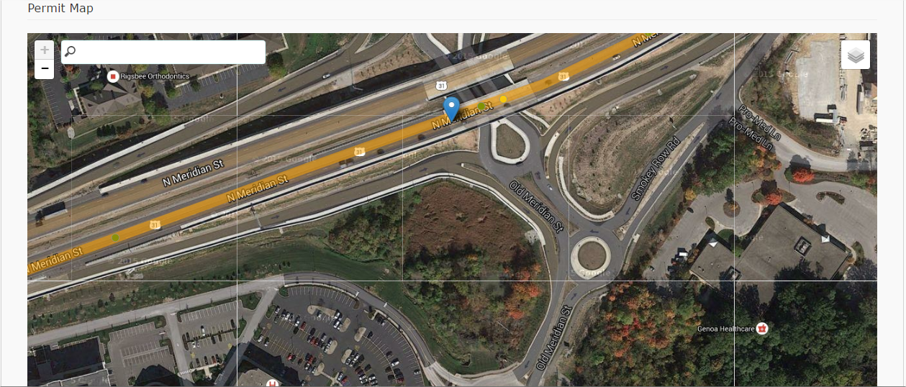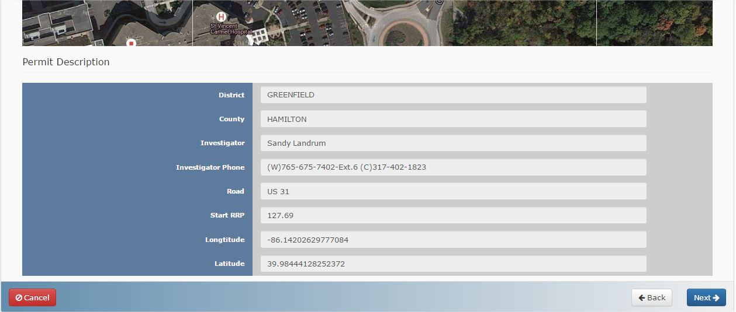

Location – Railroad
For Railroad permit applications, the Location section begins by asking for the AAR or DOT#. Enter the AAR or DOT# in the box and click Search to view more details.
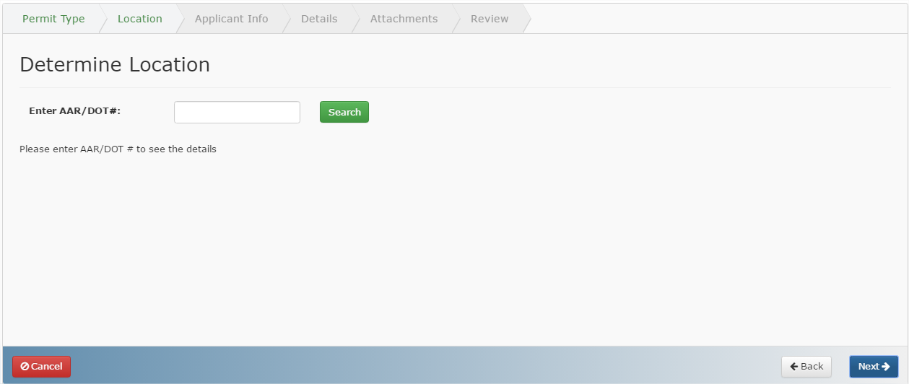
The Railroad Crossing information displays based on the entered value, and is not editable.
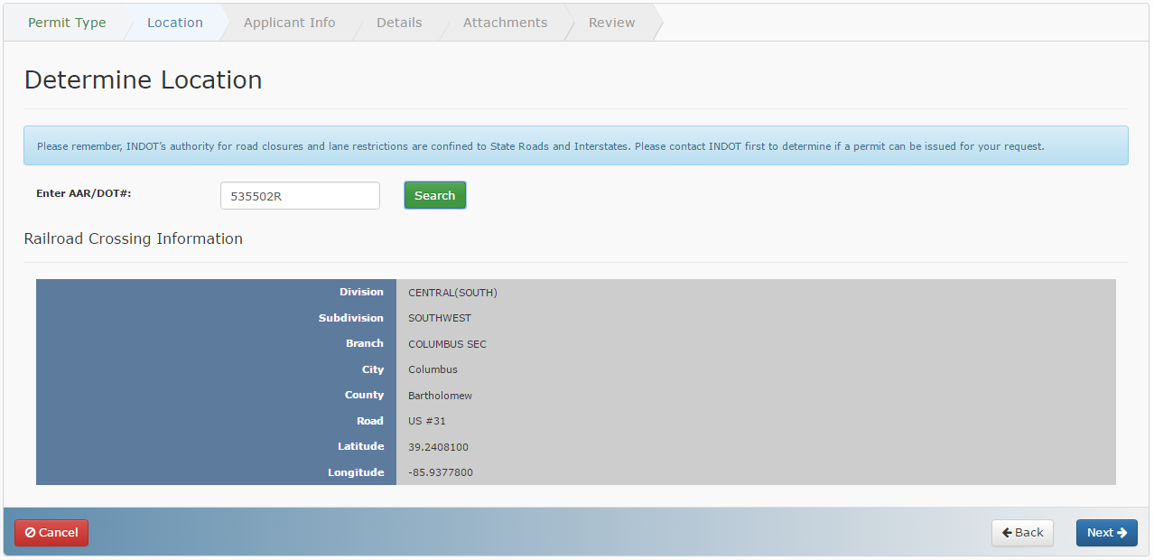
If an invalid number is entered, the search results will be blank. The permit application cannot move forward until a valid AAR/DOT# is entered.
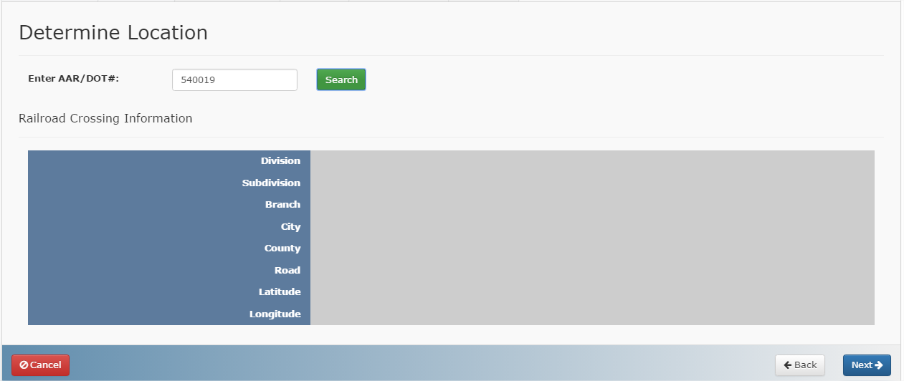

Applicant Info – FOR ALL PERMIT TYPES except Railroad
Fill out the Applicant Information as requested. Click on the black question mark next to select fields for more information on the specific field.
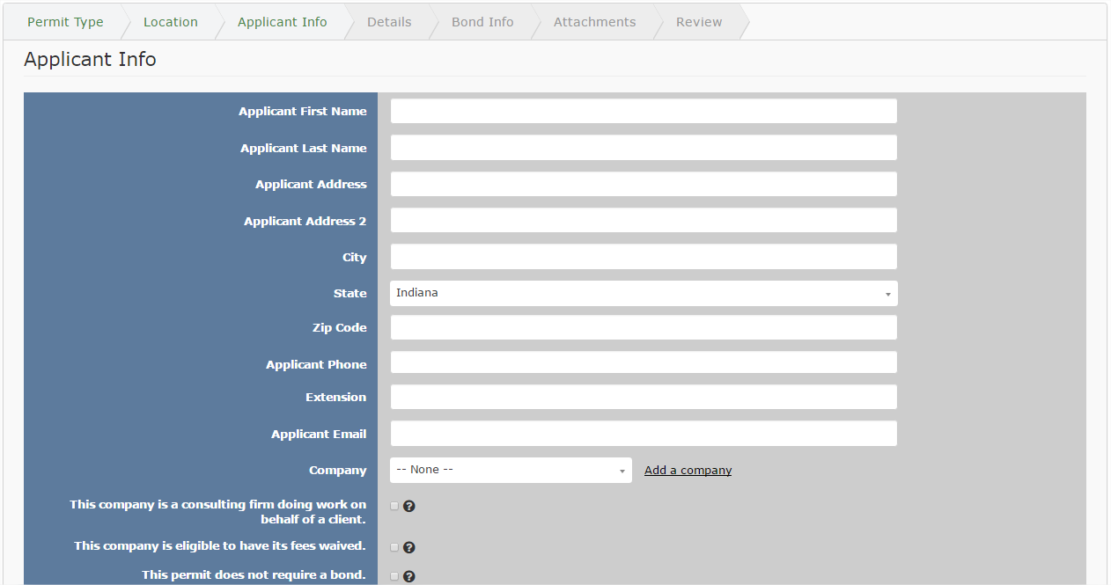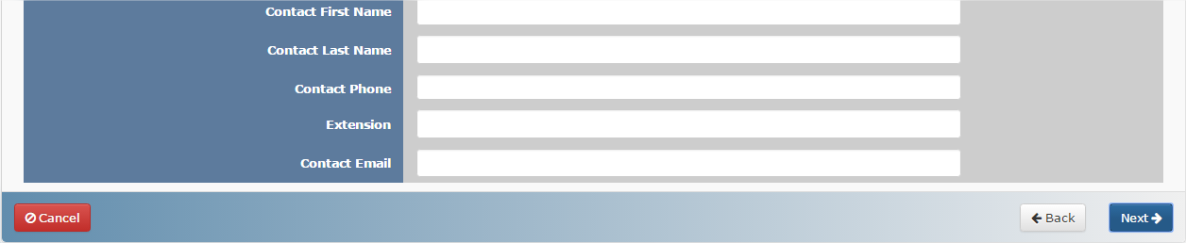
If the company is not already in the Company dropdown, click on the Add a company link.
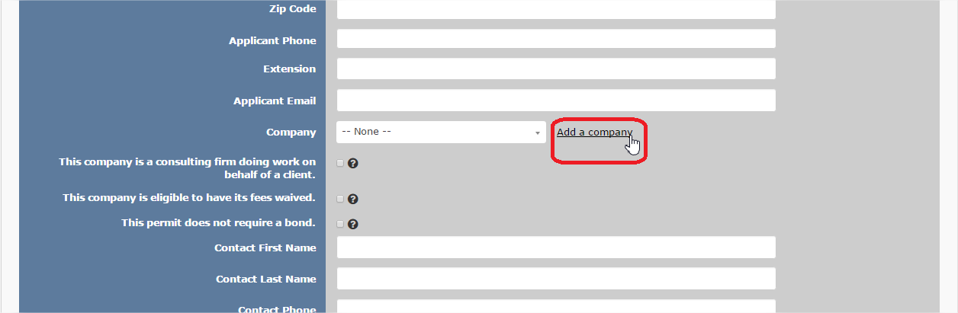

The Add Company screen opens. Enter information as necessary and click Save to save the company information or click Cancel to return to the permit application without adding a company.
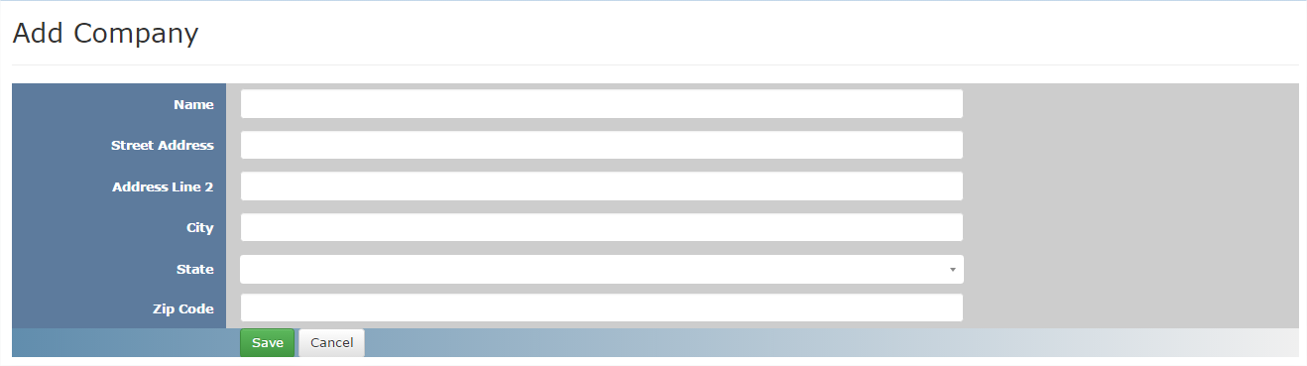
After saving the new company information, the Company Details screen displays the company information. See Companies for more information on managing users and editing company details. Click on Back to Permit to return to the permit application and resume entering Applicant Info.
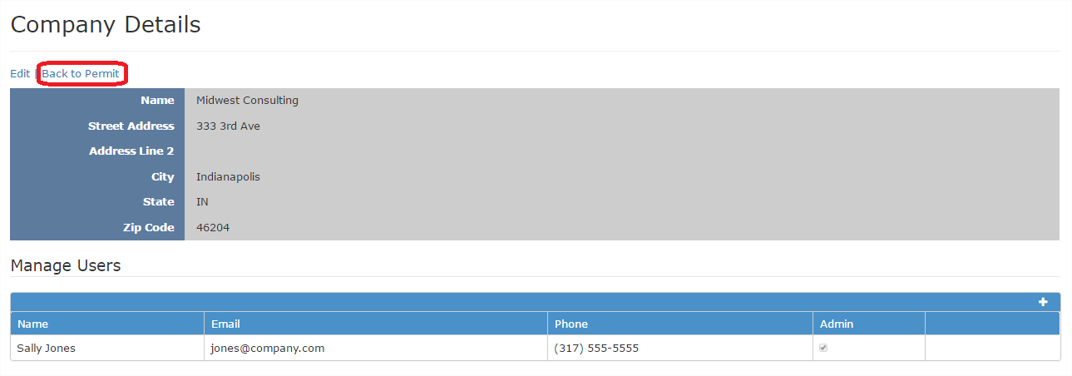
The newly added company displays in the Company dropdown.
If the Applicant is a consulting firm doing work on behalf of a Client, click in the check box This company is a consulting firm doing work on behalf of a client. Clicking in this box adds a new section to the permit application – Client Info. See Client Info for more information.
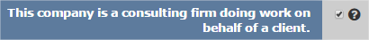

Applicant Info – Railroads
Fill out the Applicant Information as requested. Click on the black question mark next to select fields for more information on the specific field.
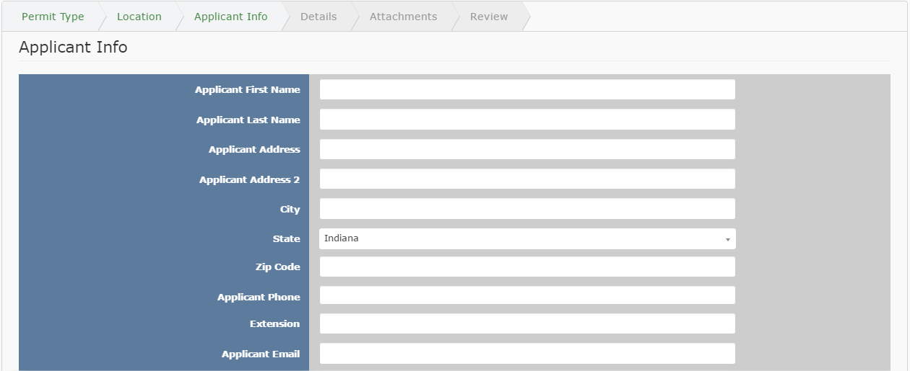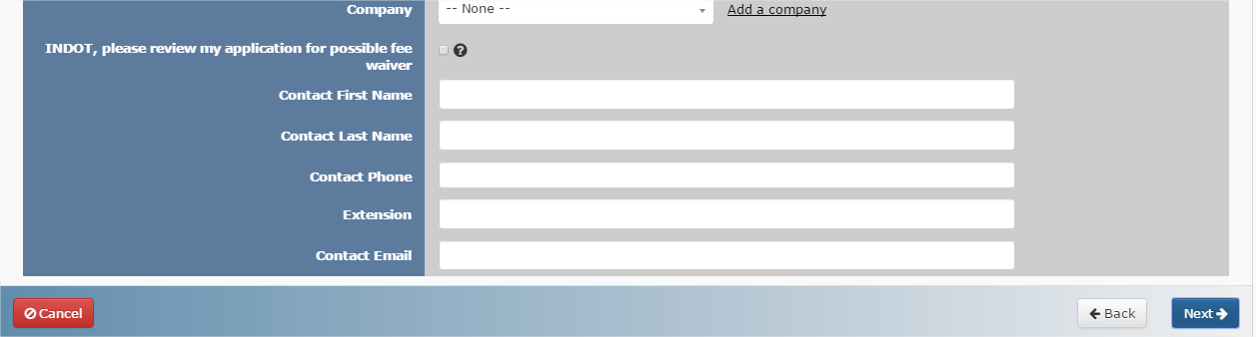

Client Info – Only for Consulting firms doing work on behalf of a Client
For Consulting firms doing work on behalf of a client, an additional Client Info section is added to the Permit Application.
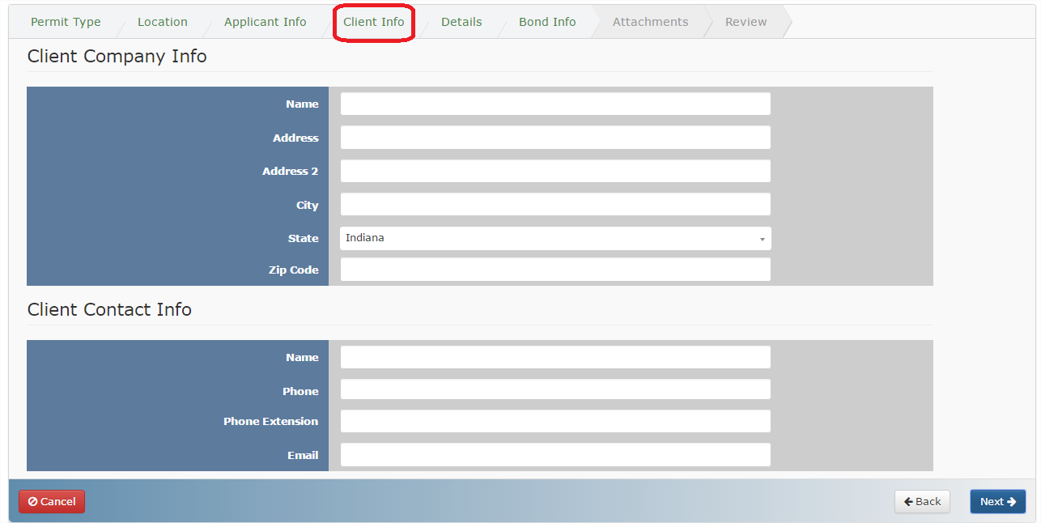
Fill out the Client Company Info in the Client Company Info section. See the chart below for information on what information to fill out in the Client Info sections:
Permit Type | Client Company Info
Cut Road, Pole Line and Miscellaneous | Owner of Utility
Driveway | Owner of Property
Outdoor Sign | Owner of Billboard
Fill out the Client Contact Info with the information of the contact person at the Client Company.
Consultants will also have to fill out and attach the Consultant Consent form in the Attachments section.
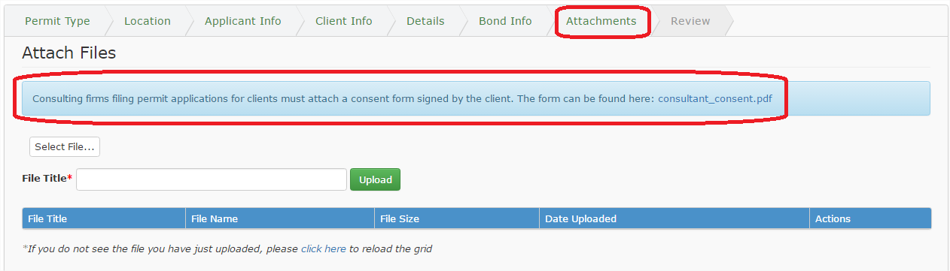

Details – FOR ALL PERMIT TYPES
Complete the details as necessary. Many of the fields are pre-populated based on the Permit Type and Location information entered earlier in the application process. Additional (or fewer) fields may display based on the type of Permit.
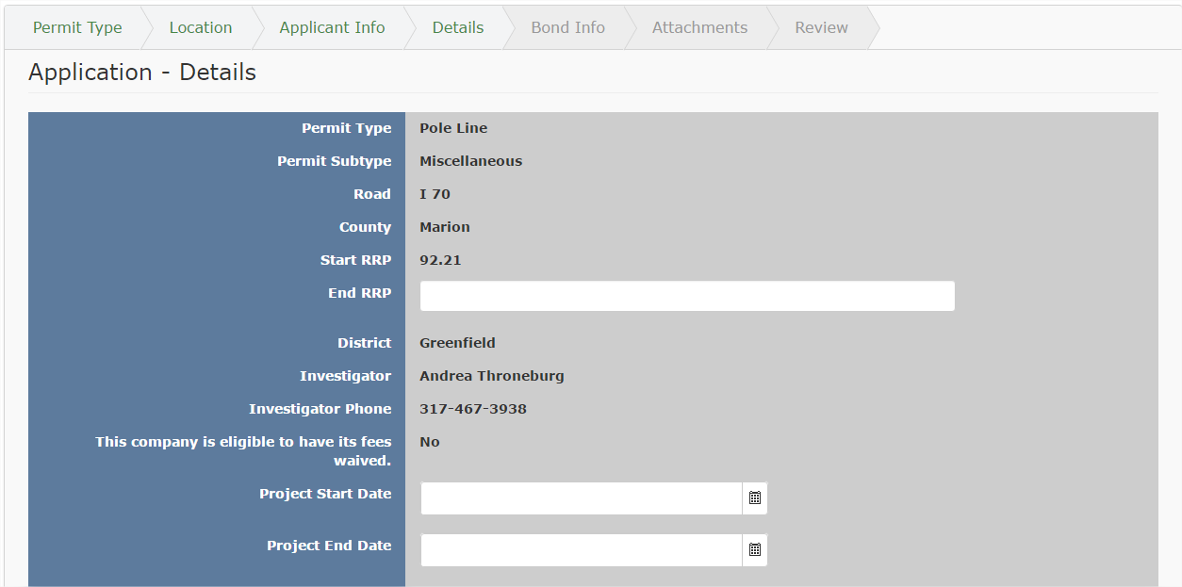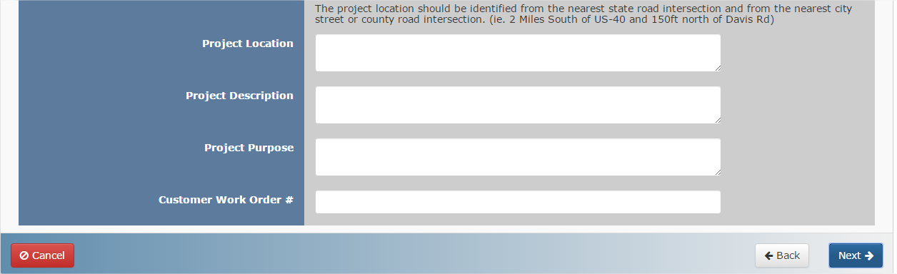

Driveway Details – Only for All Driveway Subtypes
Complete the fields on the Driveway Details screen as necessary. Many fields are required and need to be completed in order to move forward with the permit process or save. Review the questions and ensure all the answers are readily available before starting to fill in the screen.
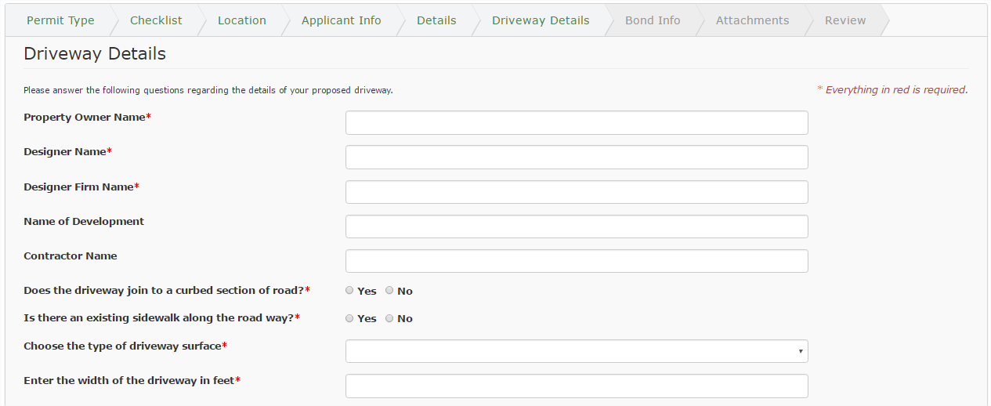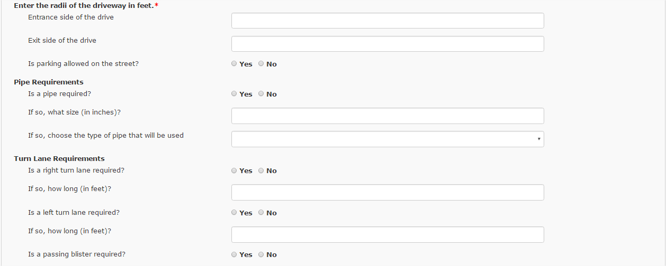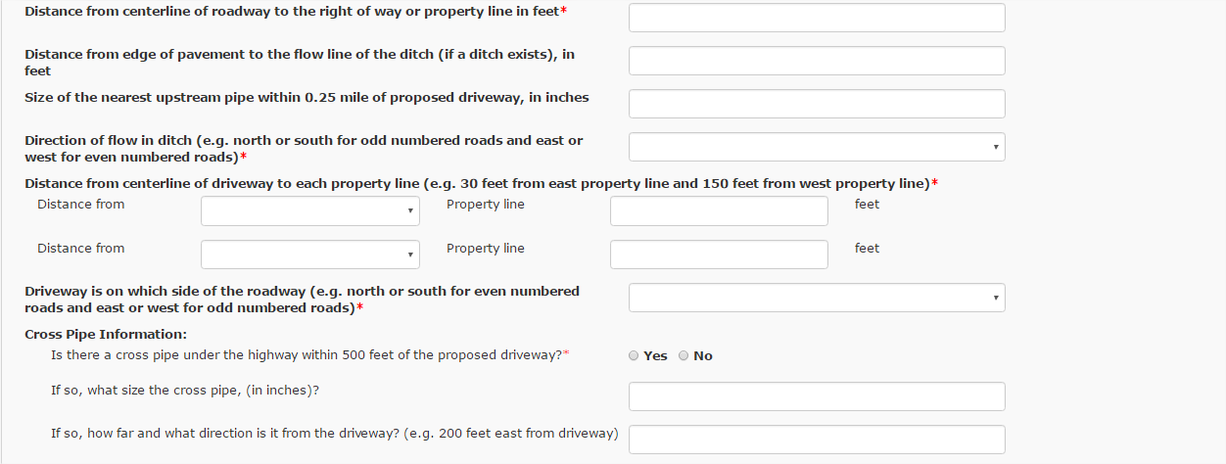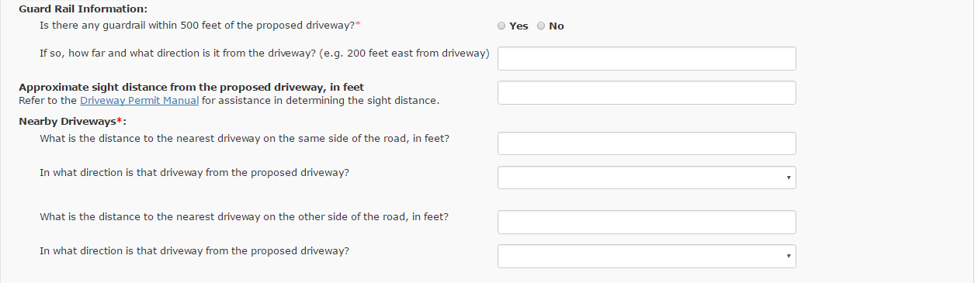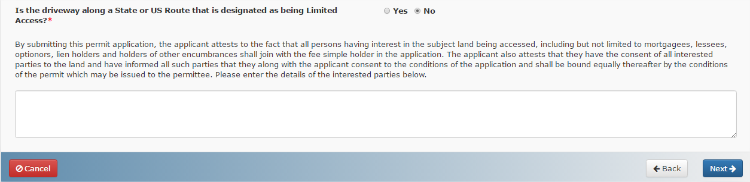
If the driveway is along a State or US Route that is designated as being Limited Access, then a warning message displays alerting the User that additional information will be required.
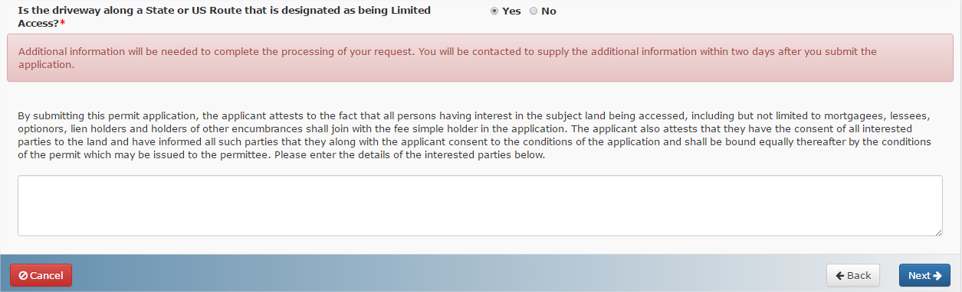

Sign Details – Only for Outdoor Signs
Complete the fields on the Sign Details screen as necessary. Many fields are required and need to be completed in order to move forward with the permit process or save. Review the questions and ensure all the answers are readily available before starting to fill in the screen.
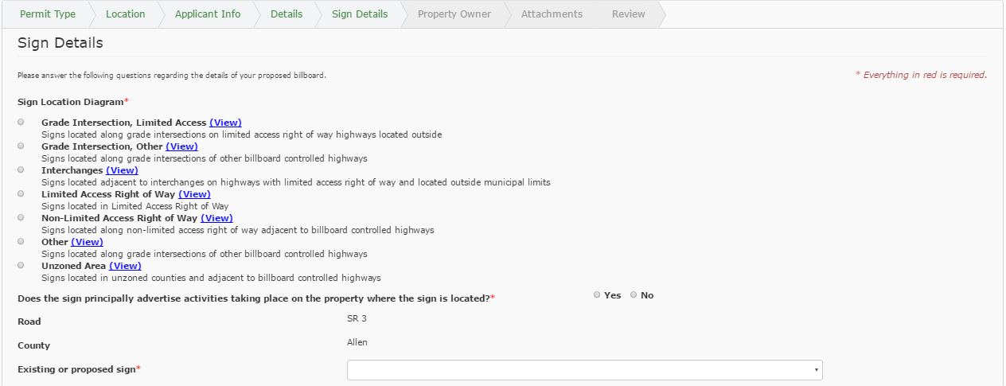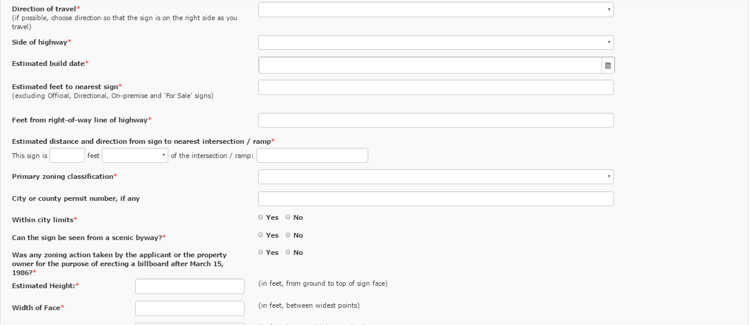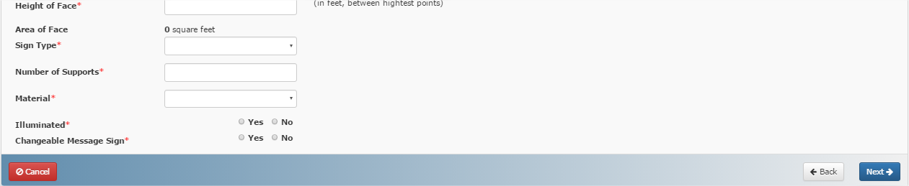
If the zoning classification is Unzoned Industrial or Unzoned Commercial, an additional dropdown field needs to be completed.
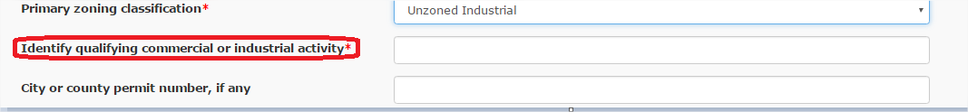
If the zoning classification is Other a text box appears for additional explanation.
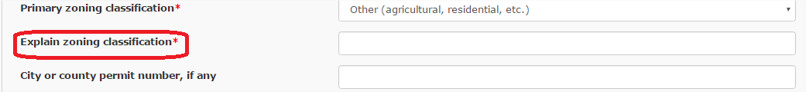
If the outdoor sign is within city limits a text box appears to denote the controlling municipality.
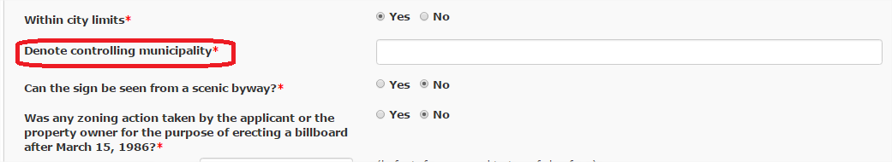
The Area of the sign is automatically calculated based on the entries for height and width of face.
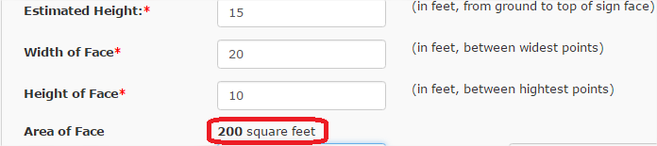
If the Sign Type is selected as Other a text field appears to specify the sign type.
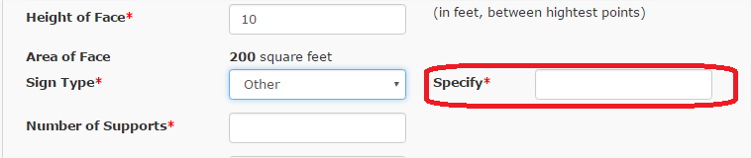
If the Material is selected as Other a text field appears to specify the material type.
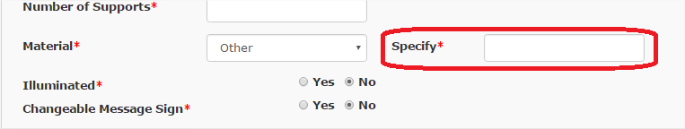

Property Owner – Only for Outdoor Signs
Complete the Property Owner details as necessary.
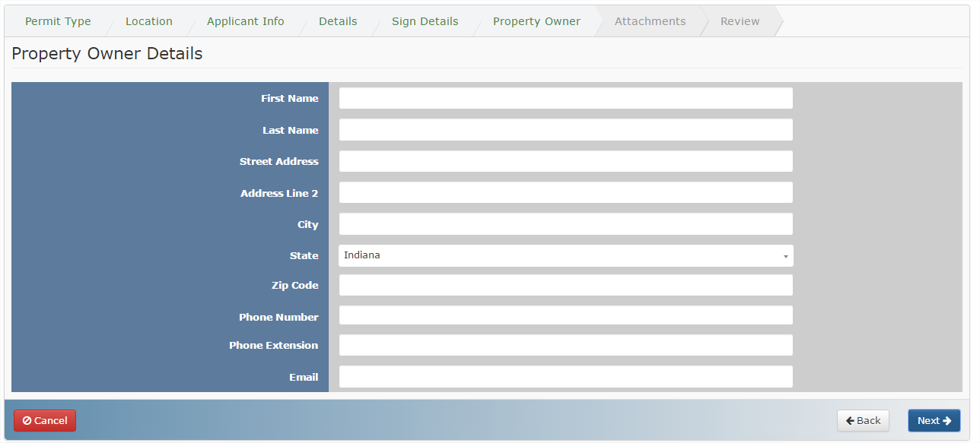

Bond Info – FOR ALL PERMIT TYPES
Enter the Bond information as necessary.
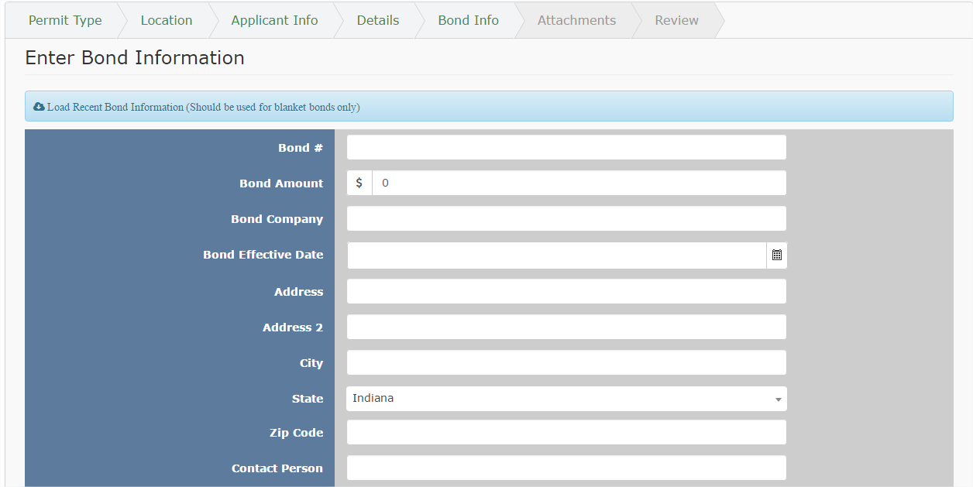
Click on the Load Recent Bond Information text to load the most recent bond information. This option should be used for blanket bonds only. If no previous bond information exists the screen will refresh but none of the fields will populate.
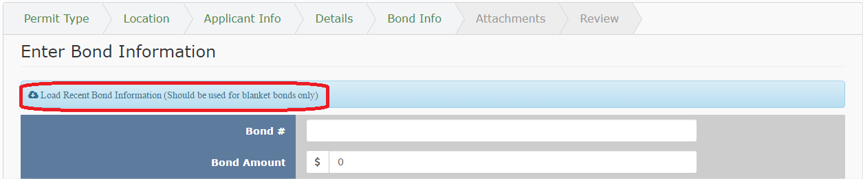

Attachments – FOR ALL PERMIT TYPES
Add any necessary files to the Permit Application on the Attachments screen. Click on the Select File… button to select the file to upload.
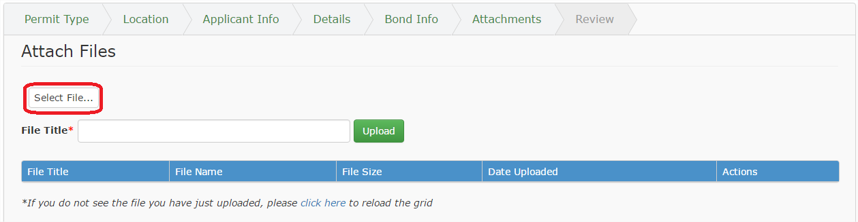
Multiple files can be added as attachments but they must be uploaded one at a time.

Navigate to the document location on your computer. Click on the document to upload. Click Open to add the document to the queue.
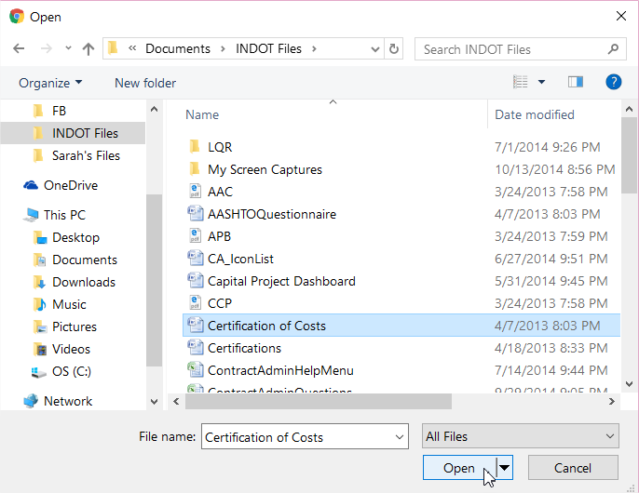
Enter the title of the document and click on the Upload button to begin uploading the document.
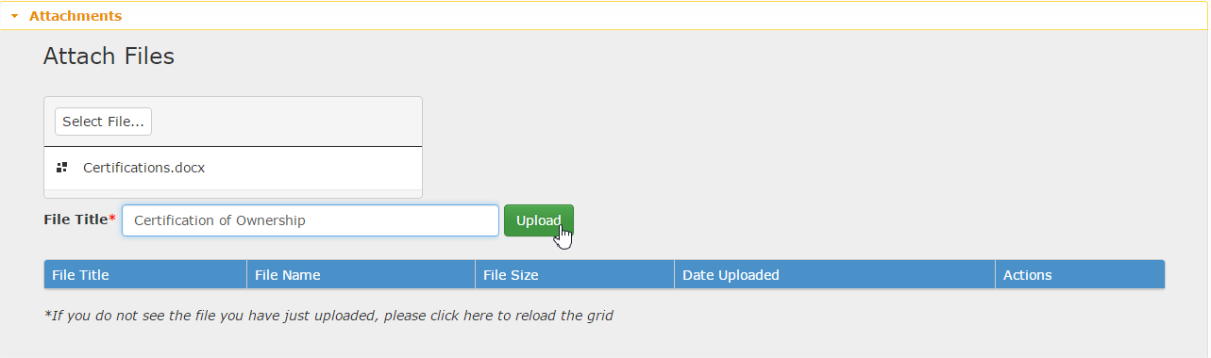

While the document is uploading the screen might display a rotating working arrow. Once the upload is complete the arrows will disappear.
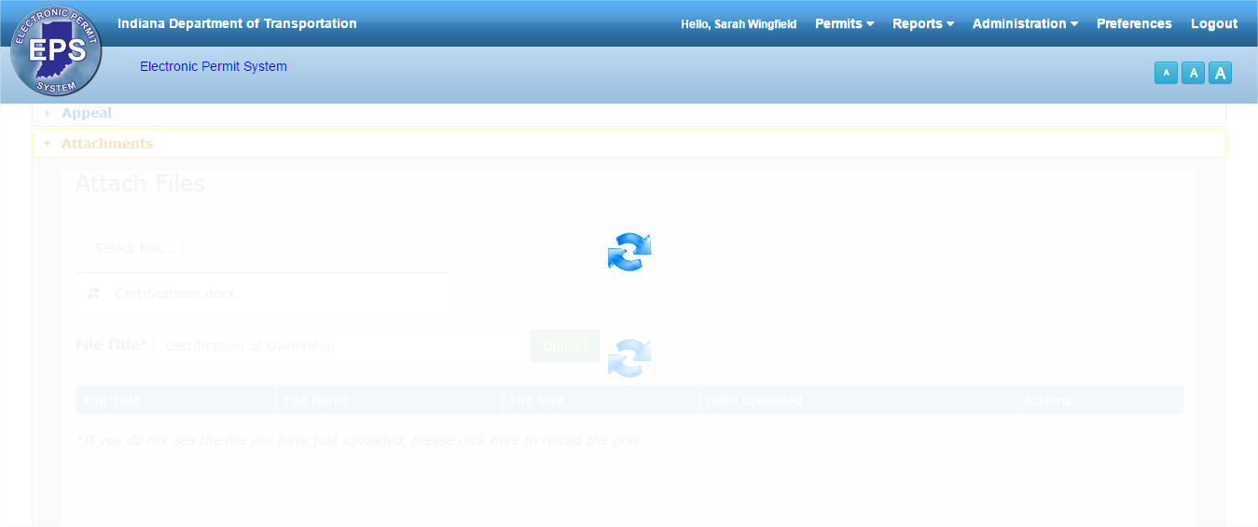
If the document is not visible in the table after the arrows disappear then click on the text that says “click here” to reload the table. The document should display after clicking click here.
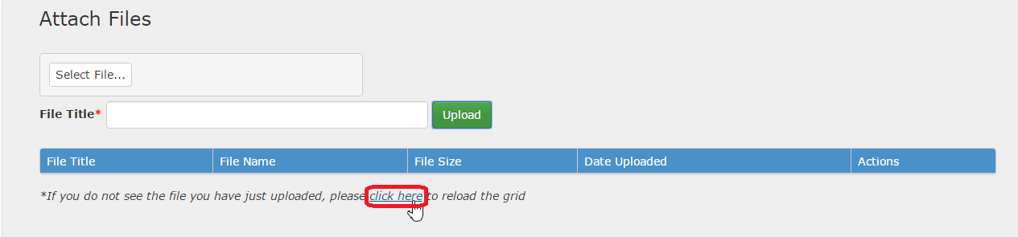
Continuing uploading files as necessary. Click on the Download Documenticon to download and view a copy of the document. Click on Delete to remove the attachment from EPS.
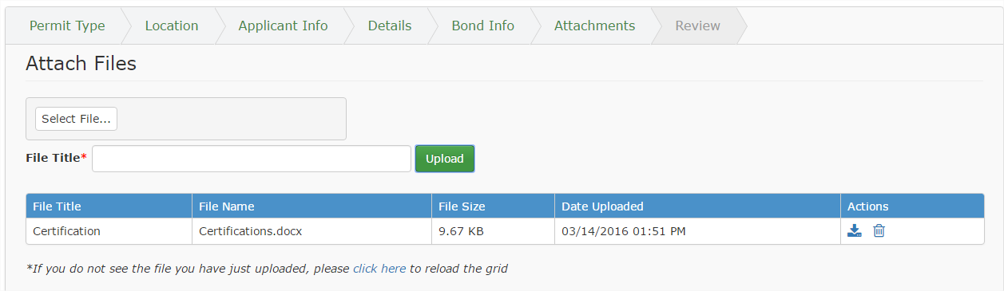

For Consultants filling out applications on behalf of a client, the Consultant Consent form must be filled out and attached to the permit application. Click on the blue consultant_consent.pdf link, complete the form and upload as described above.

Review – FOR ALL PERMIT TYPES
Review all the entered information and pay for the permit application on the Review screen. Select the permit application payment method by clicking in the check box next to the desired choice – via instant access or subscriber payment. Click Submit to submit the permit application and proceed to the payment screen.
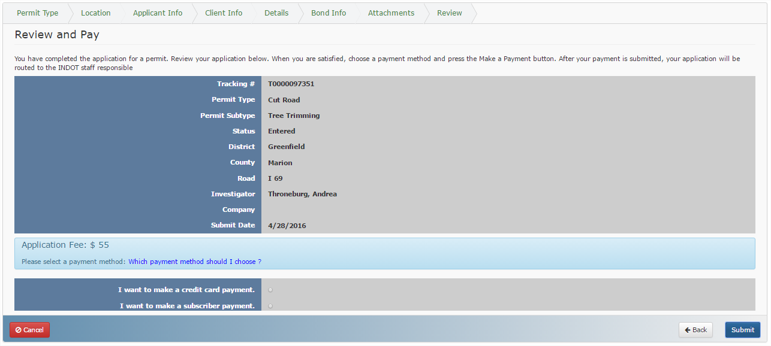
For more information on the payment types, hover or click on the Which payment method should I choose? text. Descriptions on each of the types of payment options should help clarify which payment type to choose.

The user is taken to the payment screen. Select between making a credit card payment or a Subscriber payment.

Credit Card Payment
If paying by credit card, select payment type from the dropdown and click Next.
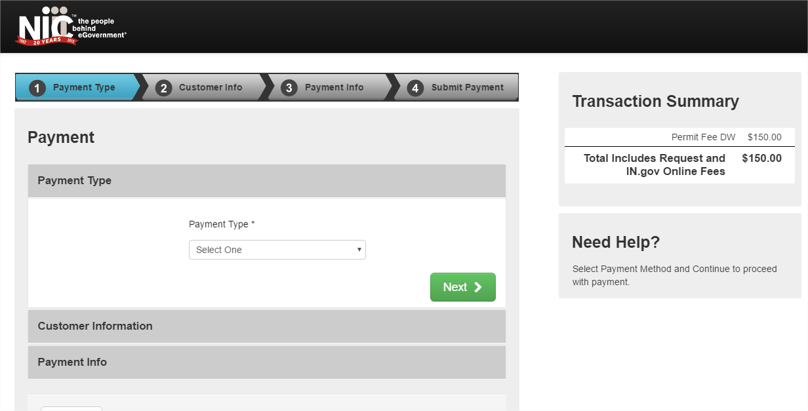

Enter the customer information and click Next to continue or click Cancel to return to the Permit Application without submitting payment.
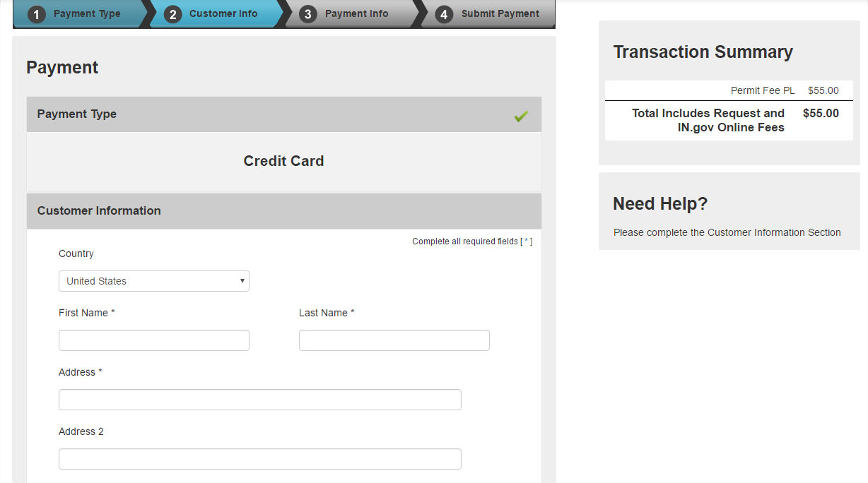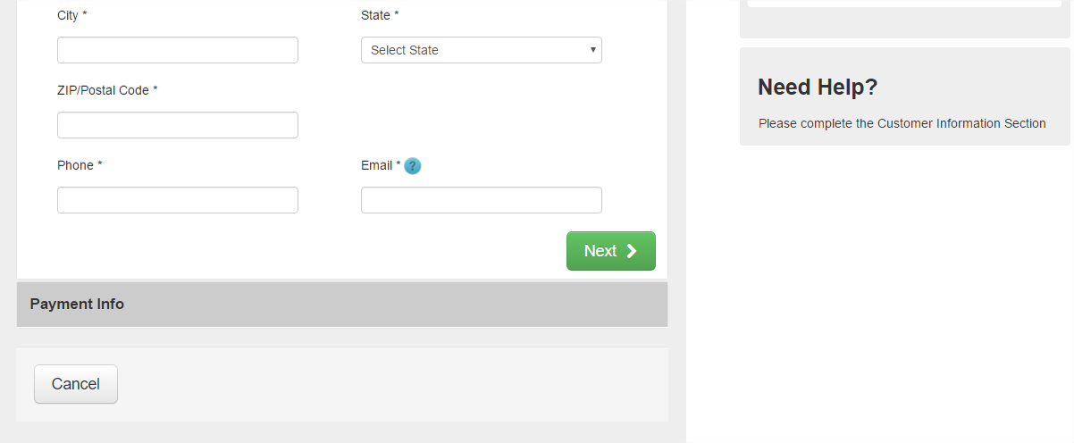

Click Edit to edit the entered customer information. Enter the credit card information as required and click
Next to complete the transaction.
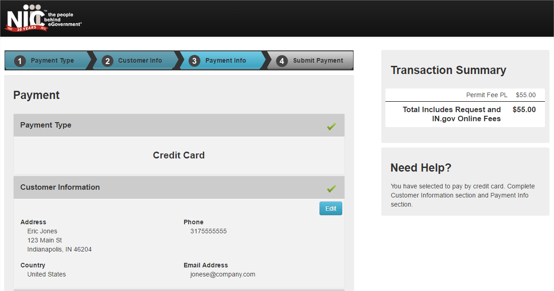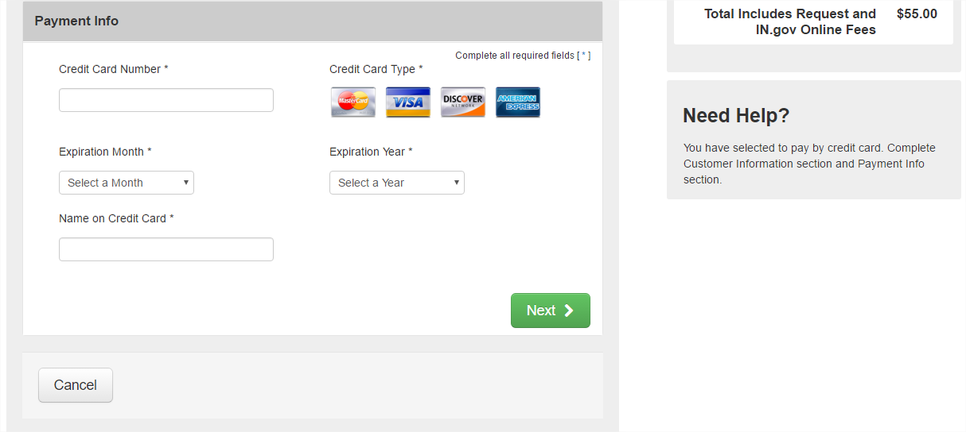

Click the Edit button in either the Customer Information or Payment Info sections to edit the entered information. When ready, click Submit Payment to submit the payment.
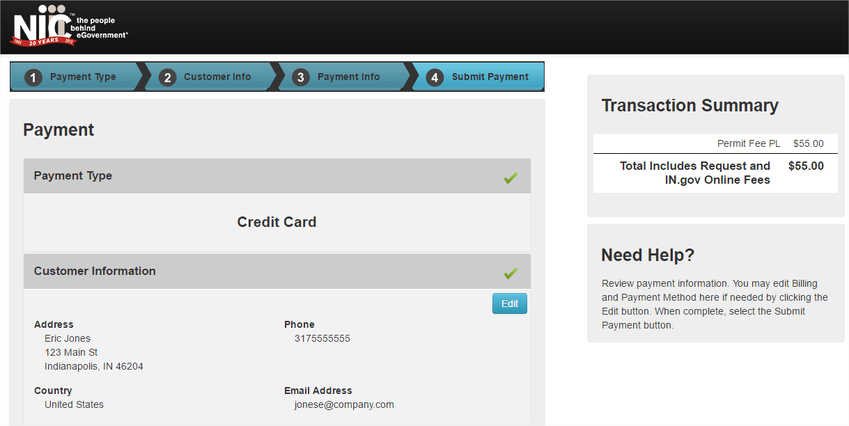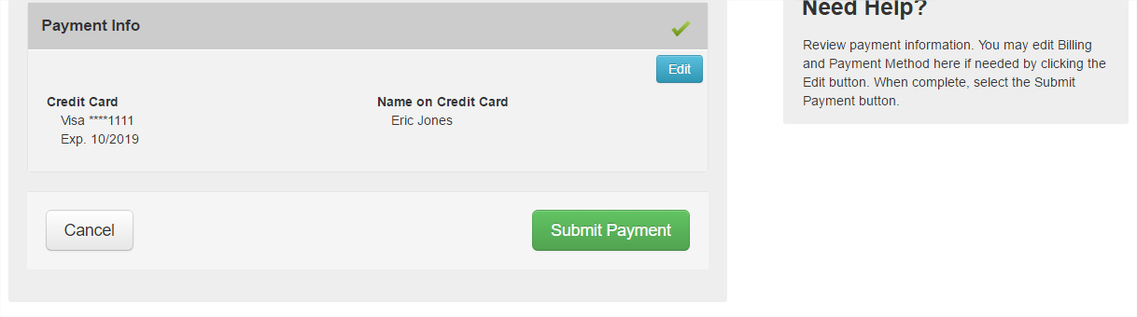

Subscriber Payment
If paying as a Subscriber, enter the subscriber Username and Password and click Next.
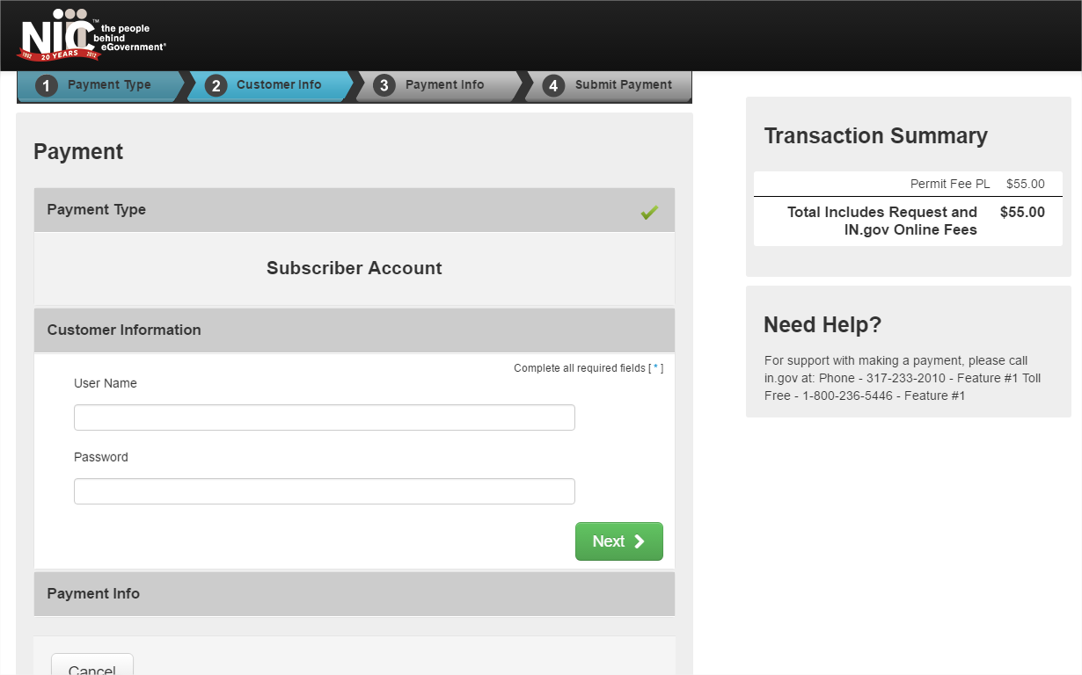
The information associated with the account displays. Click Submit Payment to have fees invoiced at a later date.
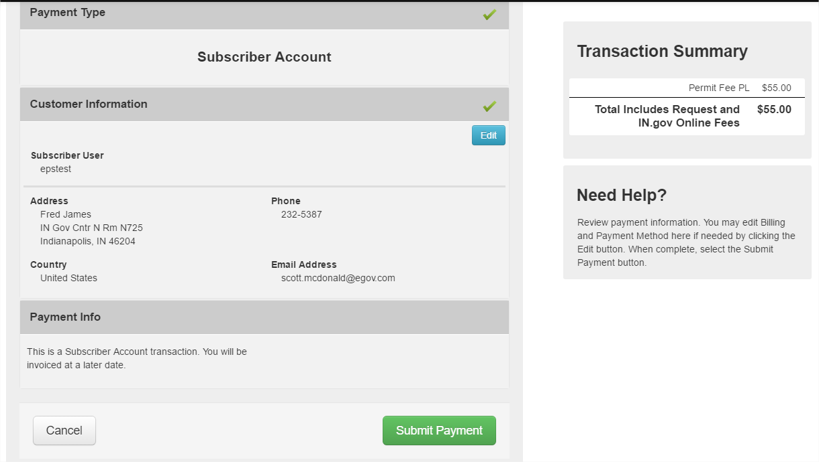
Once submitted (the method does not matter), the Review screen displays with a confirmation message that the Permit was successfully submitted. Click Done to return to the Permit Dashboard.
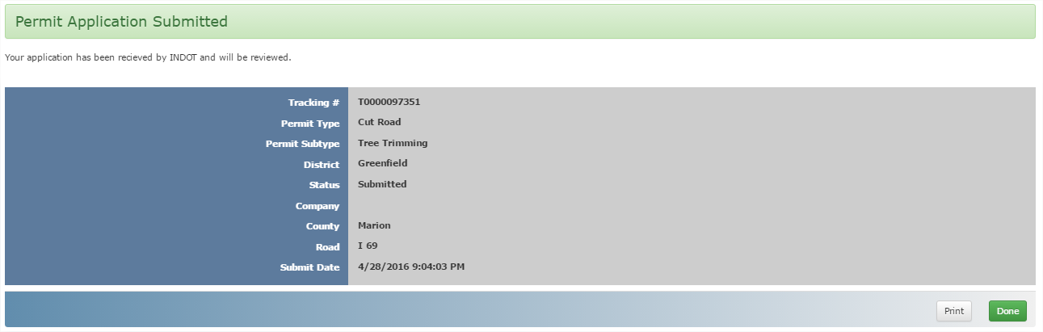
The permit application status changes from Entered to Submitted in the Permit Dashboard.
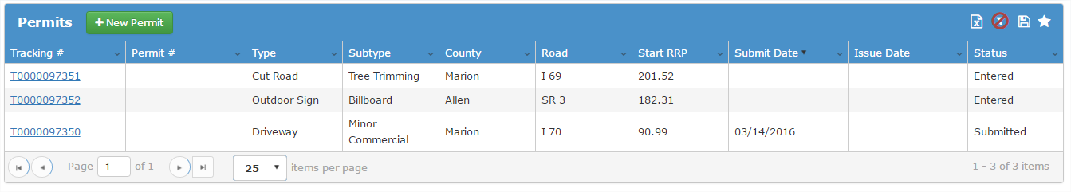

Submitted Permit Application
Once a permit application is submitted, the application can be viewed and printed, but not edited. Click on the blue section headers to expand the section and view more details on the entered information. Click the Print icon to print a copy of the application.
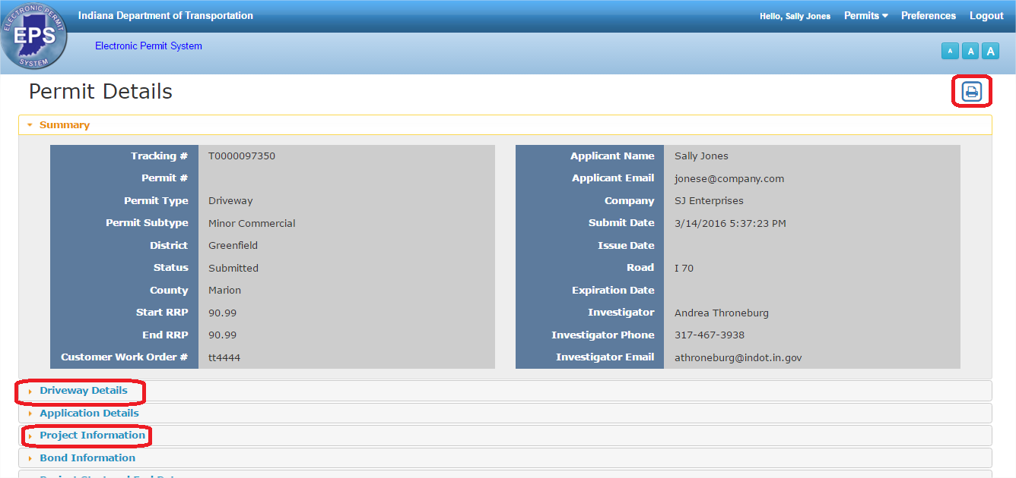
The screen refreshes and displays a PDF of the application. To return to the EPS website application, click on the browser Back button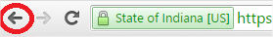.
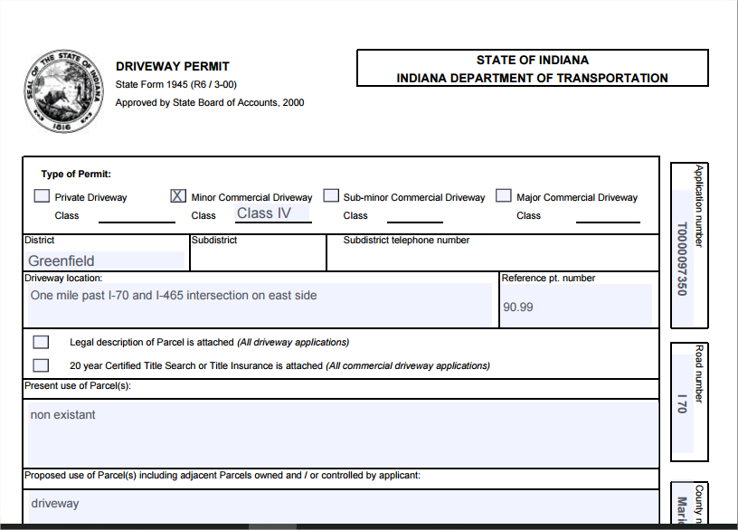
The Investigator assigned to the permit is listed in the Summary section, along with their phone number and email address.
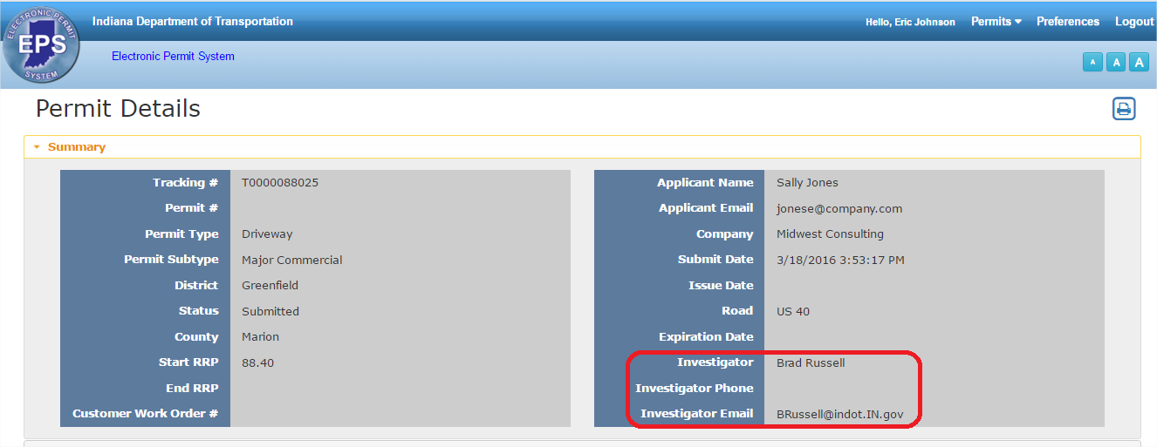
The Details sections and Bond Information section display content from the permit application, and is view only (non-editable). The Project Start and End Date section is editable. Enter the project start and end dates and click Save to save the information.
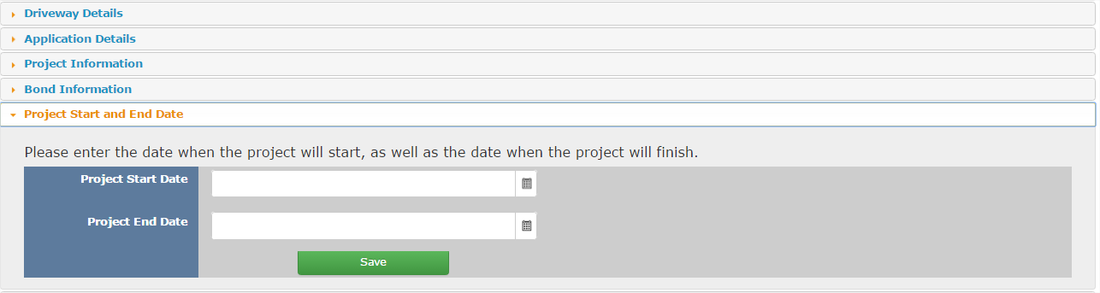
The Messages section displays any messages associated with the project. Click on the blue Subject text to open and read the message.
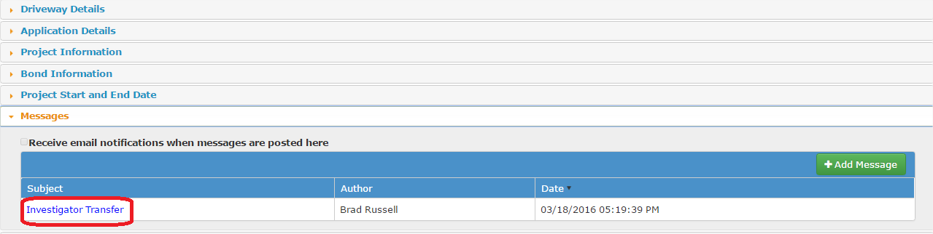
Click on the Add Message button to add a message that will be sent to (and visible to) the permit Community – the Investigator, Permit Manager, any Reviewers and the customer.
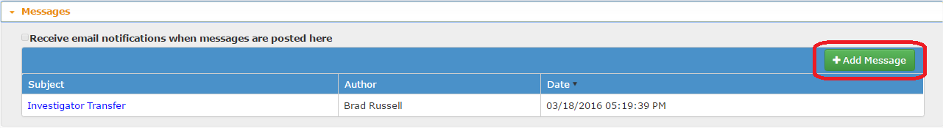

Enter the information as necessary and click Update to add the message or click Cancel to return to the permit application without adding the message.
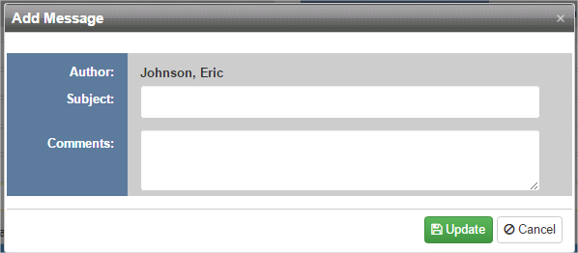
The Attachments section displays any attachments associated with the permit application. In addition to any attachments uploaded during the permit application creation process, some documents are automatically added to the application when it is submitted. Click the Download Attachment icon to download the attachment.
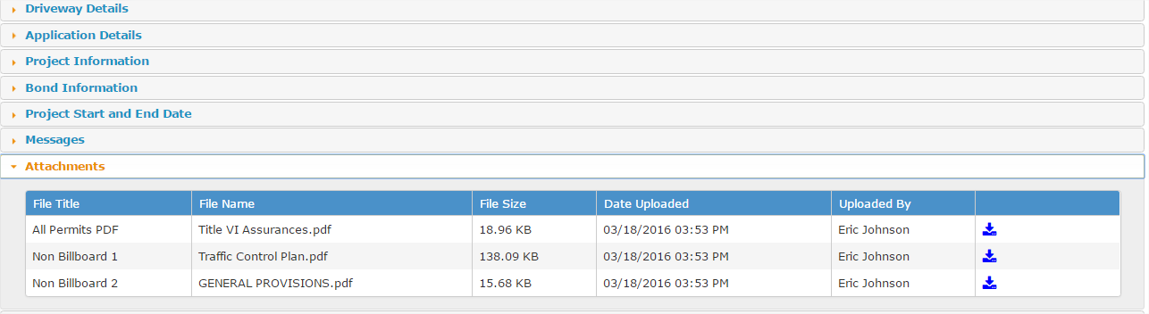
Any charges related to the application display in the Charges section. Click the Pay Now button to pay any outstanding charges.
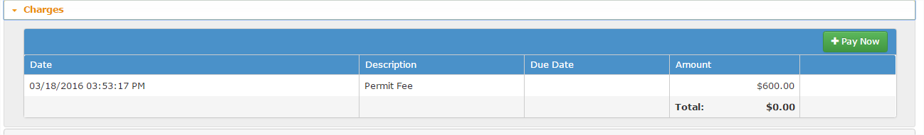

In Process Actions
When a Permit is submitted the status changes from Entered to Submitted and the approval process begins on the INDOT side. There are multiple approval steps on the INDOT side; once the first step is taken, the status changes from Submitted to In Process. The status will remain In Process until a final approval or denial decision is made.
If a request for more information from the Customer is made by the Investigator, the status changes to Customer Info Request.
If a permit application is denied, the status changes to Denied and the application can only be printed.
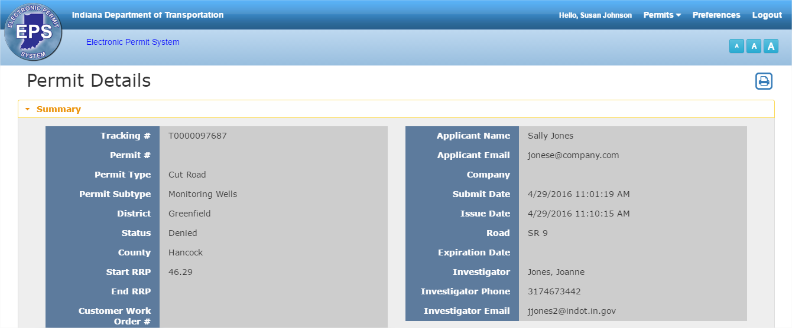
If a permit is cancelled, the status changes to Cancelled and the permit can only be printed.
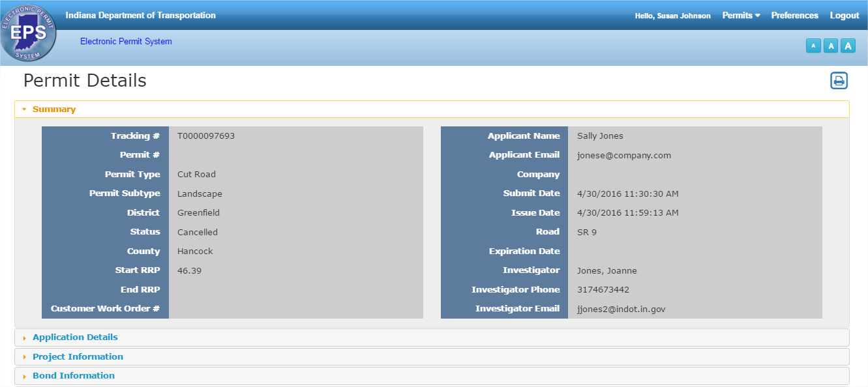

Active Permit Actions
Once a permit has been approved the application status changes to Active and the Request Extension and Addendum icons are available.
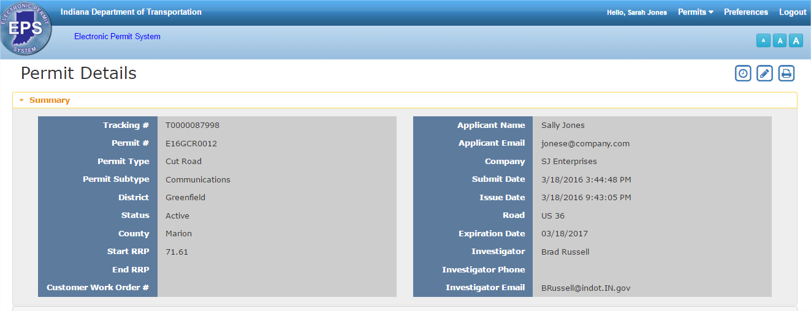
Click Request Extensionto request an extension on an active permit. Enter the new Expiration date and add Comments .Click Submit to request the extension, click Clear to clear any entered data, or click the grey to return to the permit without requesting an extension.
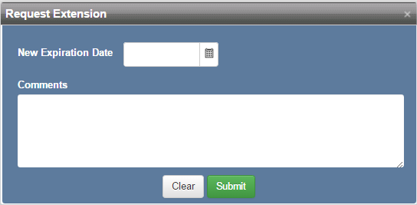

Click Addendumto create an addendum to an existing Active permit. The information entered into the original permit will be copied over to a new Permit Application, and the new Permit Application will receive its own Tracking # and the status will be Addendum Created.
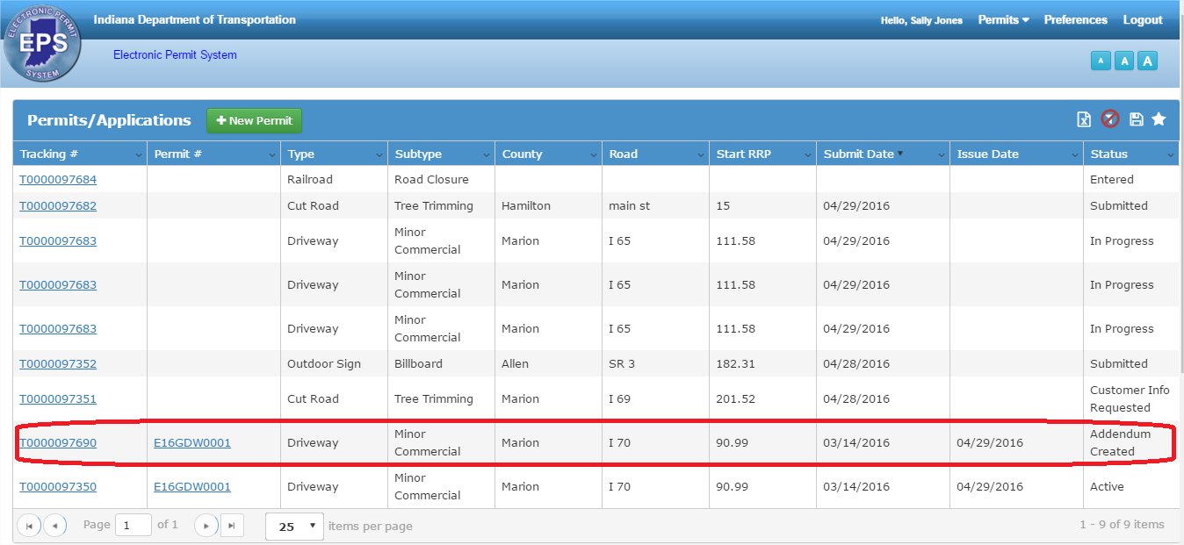
Click on the blue Tracking # to open the addendum. Complete the permit application information, making updates where necessary, as described in the New Permit Application section.

Preferences
The Preferences screen allows Users to edit their User Profile information and update their password.

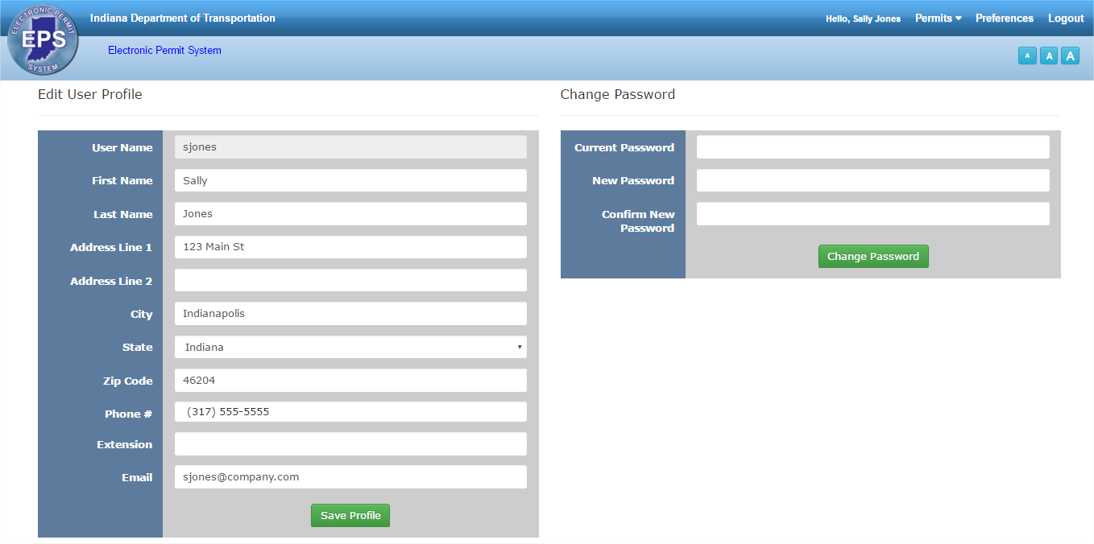

To update User Profile information, make changes as necessary and click Save Profile to save the updates.
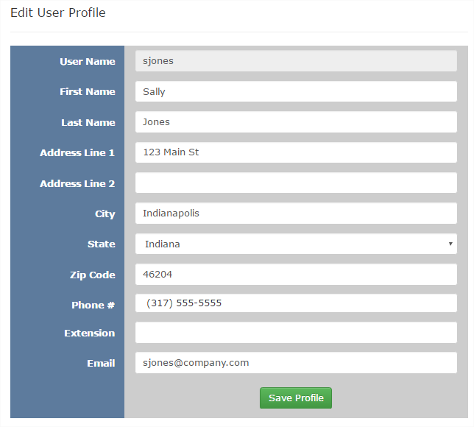
Any system emails and password resets will be sent to the email address listed in the profile.

To change the User password, first enter the current password. Then enter a new password and retype to confirm. Click Change Password to save the changed password.
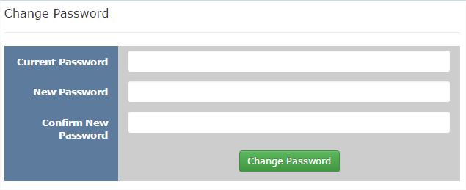

Permit Type and Subtype Table
Use the table below as a reference for the different permit types and subtypes used to create a permit application.
Permit Type | Permit Subtypes
Pole Line | Communications  Miscellaneous  Electric
Cut Road | Environmental Spill  Monitoring Wells  Tree Trimming  Landscape  Communications  Gas  Electric  Water  Railroad Crossing  Steam  Miscellaneous  Drainage  Logo  Cell Tower  Sewer
Driveway | Private  Major Commercial  Major Road Approach  Minor Commercial  Minor Road Approach
Outdoor Sign | Billboard
Miscellaneous | Banner  Road Closure  Coffee Safety Stops  Miscellaneous  Adopt a Highway

